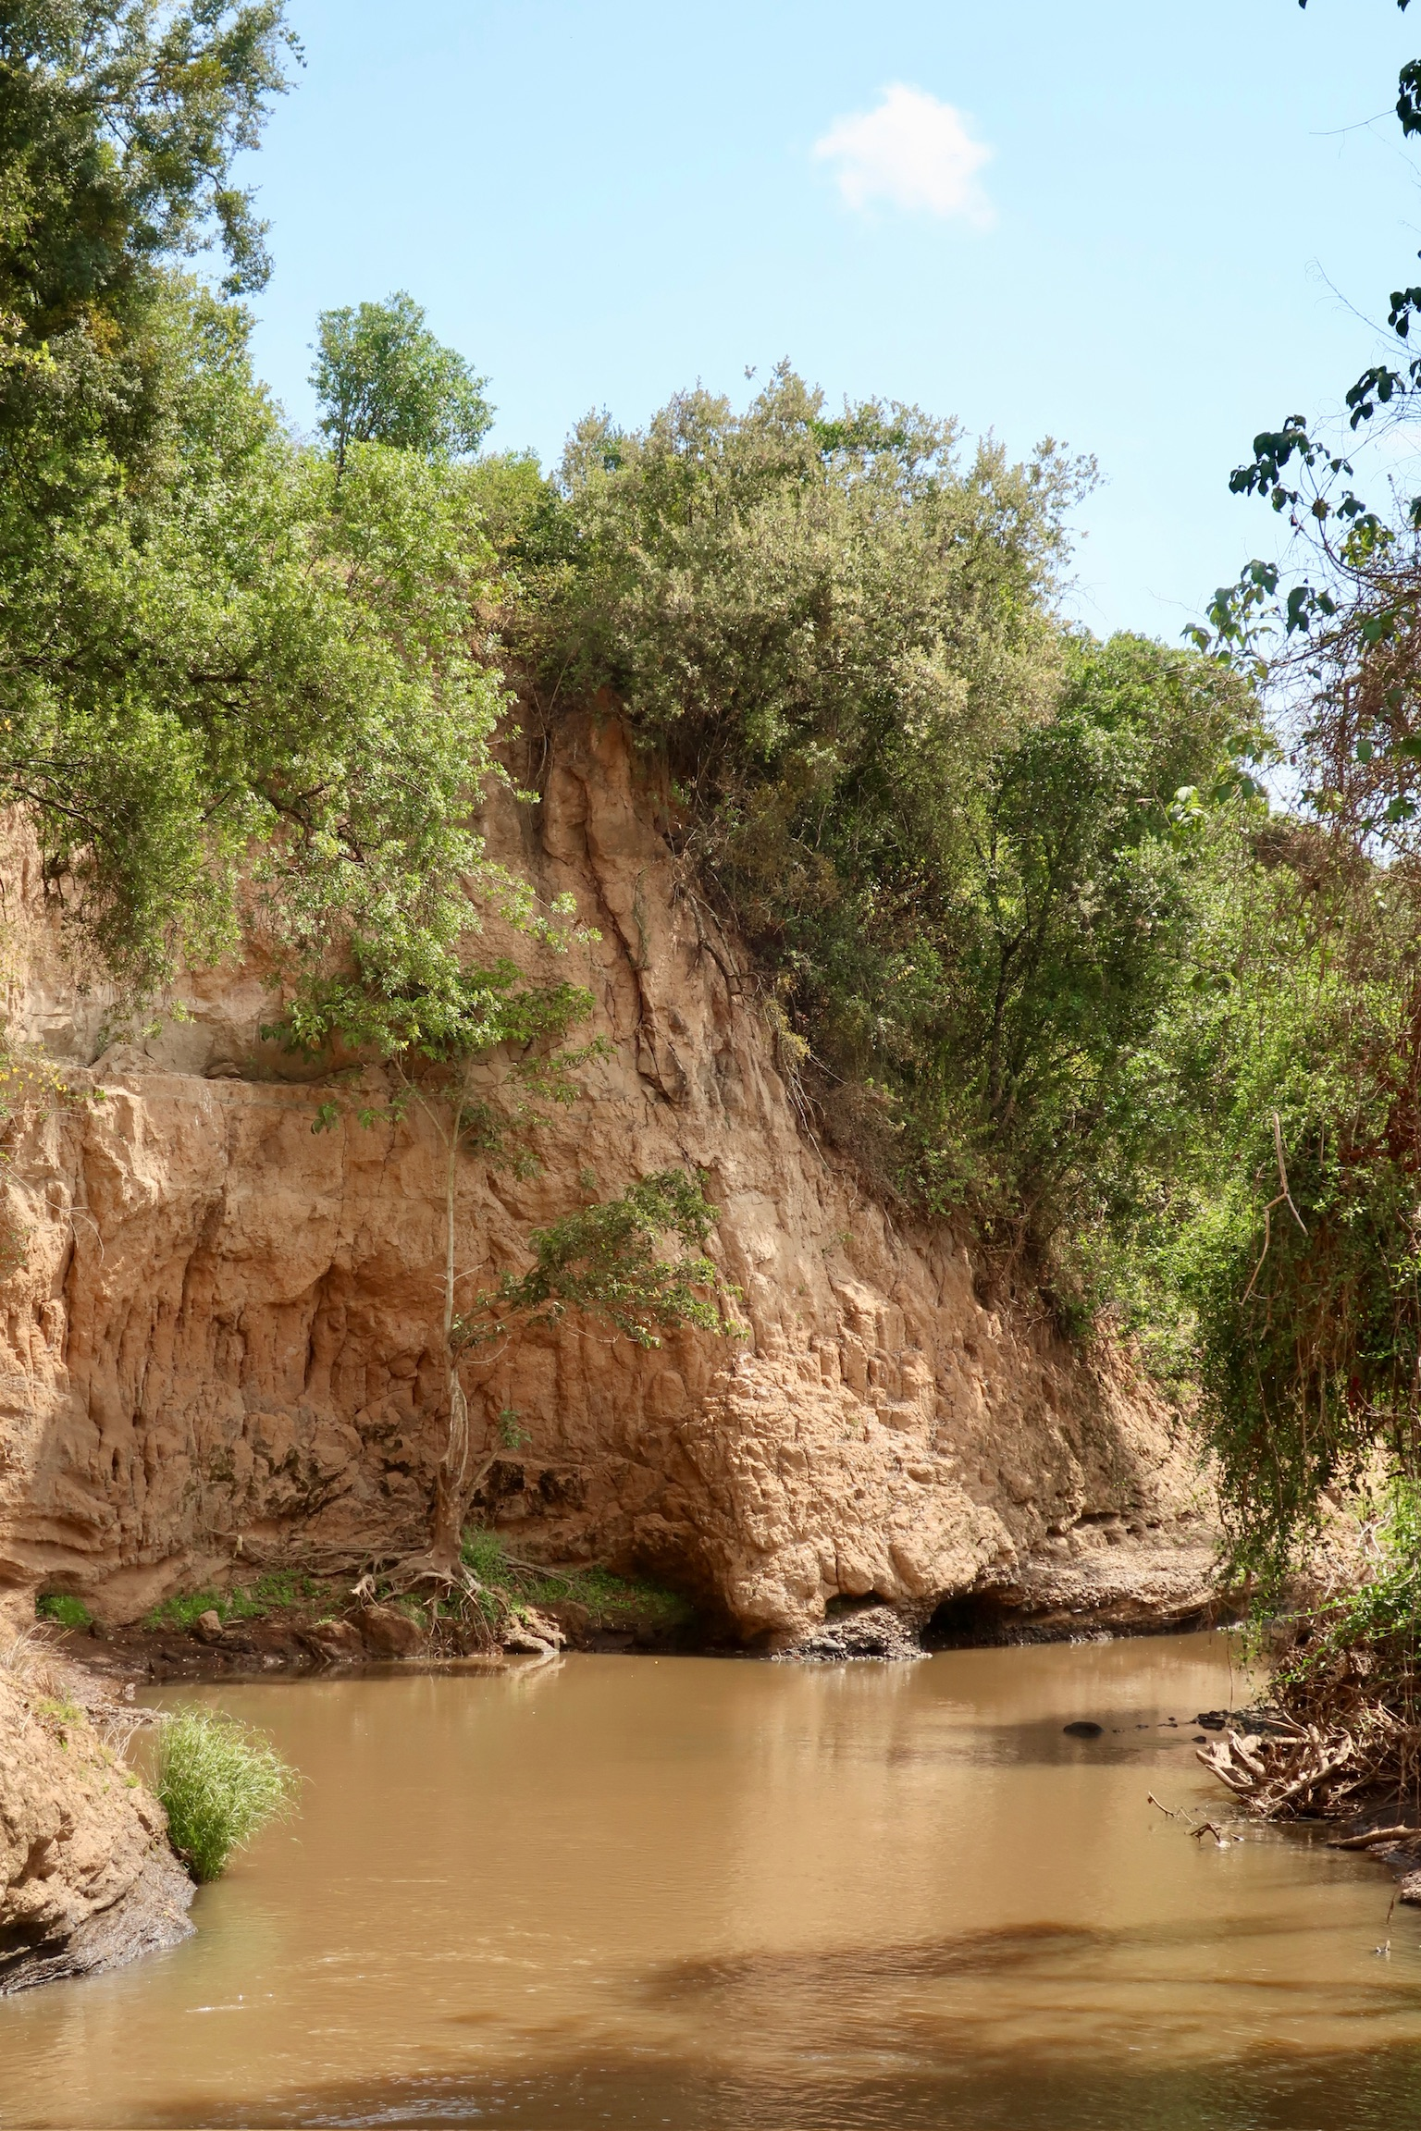Implementation of a Flood Early Warning System in Narok Town, Kenya

***“A case study corresponding to the document “Manual for the implementation of a flood early warning system in small urban areas in africa”***

Tim van Binsbergen, Evira Eman, Lars Heijboer,

Emmanuel Weizenbach & Lisette de Valk

October 2024, Narok Town



Preface

This document, together with the “Manual for the implementation of a flood early warning system in small urban areas in Africa”, are written as part of the course CEGM3000 Multidisciplinary Project in the MSc programmes Civil Engineering and Environmental Engineering of TU Delft. We want to express our gratitude to our supervisors, Dr. Ir. Nick van de Giesen and Frank Annor.

The main objective of this multi-disciplinary project is to "*design a flood early warning system to reduce the impact and damage of flash floods in Narok town, Kenya*”. The obtained methodology and findings are used to write a manual for the design and implementation of flood early warning systems in similar small urban areas in Africa. This manual should be easily readable and is written in a step-by-step manner. The target audience is anyone who is concerned about the impact of (flash) floods of rivers in small urban areas in Africa, for example municipalities, county governments, water authorities, or meteorological departments.

This document is meant as a guidance next to the manual, and gives an example on how the manual could be interpreted on a small town in Africa. The document follows the same structure as the manual. Per chapter the results are given and discussed. For some steps, the methodology of the case study deviates from the suggested methodology of the manual. In this case, elaboration will be given to the considerations that were made. In chapter 1, a description of the flooding problems in Narok Town is given, together with a brief analysis of the water system and possible causes for the floods. Chapter 2 will elaborate on boundaries of the river system that is accounted for in the FEWS design. This is based on the warning time for the system and the identified bottleneck. In this chapter, some other spatial statistics and visuals are given as well. In Chapter 3, results are given of the field measurements at the Enkare Narok River. After processing, the final results are shown in Chapter 4. Subsequently, the gathered data is processed in a 1D-flow model, called HEC-RAS. The model is shown and illustrated in Chapter 5. Simulations that were run in this model, are given in Chapter 6. Finally, in Chapters 7 and 8, the proposed design and implementation method are discussed. For these steps however, only a suggested approach is given. The FEWS is not actually implemented in the area.

This project was carried out in collaboration with TEMBO, an organization focused on closing the environmental data gap in Africa. TEMBO’s goal is to create affordable sensor networks that are supported by climate services built around them. Currently, their services include Flood Early Warning Systems, Water Reservoir Management, and Agricultural Information. TEMBO works closely with TAHMO and TU Delft. (TEMBO, 2024)

We had the pleasure of working with the Kenyan Meteorological Department (KMD), particularly Josiah Kahuthu; the Water Resources Authority of Kenya, with special thanks to Anne Wamuyu; and Maasai Mara University in Narok, Kenya, with appreciation to Dr. Samson Mabwoga and Simon Raphael. We’re very grateful to these individuals and organizations for their valuable contributions.

TIM VAN BINSBERGEN, EVIRA EMAN, LARS HEIJBOER,

EMMANUEL WEIZENBACH & LISETTE DE VALK

OCTOBER 2024, NAROK TOWN, KENYA

Table of content

Introduction 4

1. Investigate the flooding problem 6

1.1 First environmental analysis 6

1.2 Local authorities 7

1.2.1 Kenya Meteorological Department 7

1.2.2 Water Resources Authority 7

1.2.3 Maasai Mara University 8

1.2.5 Findings and conclusions 8

1.3 Local community 8

1.4 Literature study 9

1.4.1 Esamburmbur and Kakia catchments 9

1.4.2 Deforestation and heavy rainfall in the mau forest 10

1.4.3 Existing LOCAL warning systems 10

1.4.4 Flood Prone Area in Narok Town 10

1.4.5 Critical precipitation amounts 11

1.5 Media sources 11

1.5.1 Past Flood Events 11

1.5.2 Current Flood risk-reducing measures 12

1.6 Conclusion 12

2. Boundaries of the river reach and spatial analysis 14

2.1 Identification of the flood point 14

2.2 Identification of the gauge placement 14

2.2.1 Warning time 14

2.2.2 Flow velocity of a (flash) flood 16

2.2.3 Conclusion 16

2.3 Spatial analysis of the river reach and corresponding catchment 17

2.3.1 (sub) catchments of the river reach 18

3. Map the river 19

3.1 Exploration of cross-sections 19

3.2 Incorporation of Junctions 20

3.2.1 Eastern side stream at 6 km upstream 20

3.2.2 Drainage channel in town 20

3.3 GPS system and background 21

3.4 Preparing a measurement day 22

3.5 Execution of a measurement 23

3.5.1 Determine a suitable cross section and its bankfull state 23

3.5.2 Cross section measurement 24

3.5.3 Water elevation measurement 24

3.5.4 Length profile 24

3.5.5 Velocity profile 24

3.5.6 Slope of the river 25

3.6 Conclusion 25

4. Process data 26

4.1 RTK Software processing 26

4.2 python processing 26

4.3 Conclusion 28

5. Build model 29

5.1 Alternative manual computations 29

5.2 Modelling a flash flood 29

5.2.1 Geometry 29

5.2.2 Steady Flow 31

5.2.3 Unsteady flow 31

5.3 Models 32

5.4 Conslusion based on complete line model 33

5.4.1 The case of narok town 33

5.5 Sensitivity analysis 35

Conclusion 36

6. Implementation 37

6.1 Partners involved 37

6.2 Functioning of the system 37

6.2.1 Processing the warning 37

6.2.2 Communication of the warning 37

6.3 Selecting a sensor 38

6.4 Installation of the sensor 38

6.4.1 Location 38

6.4.2 Installation 39

6.4.3 Maintenance 39

Bibliography 40

Appendix A. Student Input Warning Time 42

Appendix B. Results calculations without a HEC-RAS model 47

Appendix C. Student input installation and functioning of the FEWS 50

Introduction

Narok Town, in the Southwest of Kenya, has a history of frequent flash floods. These floods have a large impact on the lives of the inhabitants of Narok, as they cause loss of life and livestock, damage to homes and businesses, contamination of water supplies, and social instability. The floods are primarily caused by a combination of heavy rains in upstream areas and an inadequate drainage system in town. Although efforts have been made to improve Narok's drainage system, challenges are faced due to the substantial financial and technical resources required. Given the difficulty of fully preventing flooding, the concept of a Flood Early Warning System (FEWS) has been proposed. A warning to the town before a flood will occur, can reduce the impact and damage of such a flood.

Flood early warning systems are not new to the town and the region; already many attempts have been made to make such a warning system work, however with limited success. Triggers for early warning models may include weather predictions, rainfall measurements, or water level gauges. Currently, none of the official warning systems that were designed are still in place. Informal warnings are given through personal contacts and rainfall predictions are given through a WhatsApp group, which is managed by the Kenyan Meteorological Department. A lack of official and properly maintained warning systems is common for small urban areas (<700,000 inhabitants) in Africa, but the utility could be high. Therefore, there is a need for affordable, low-maintenance and easy-to-design flood early warning systems for similar riverine (flash) floods like the case in Narok Town. (TEMBO Africa, 2024)

Narok Town, and Narok County, have been subject to similar feasibility studies in recent years. The town is located in a valley, and therefore the point of convergence for multiple water streams. The Enkare Narok river is the main water stream in this part of the Rift Valley. The source lies at the Mau Escarpment, approximately 60 kilometres to the north of Narok Town, and the river drains into the major Ewaso Ngiro river. At the border of Kenya and Tanzania, this river drains into Lake Natron. The Enkare Narok river, whose name was given by Maasai, meaning ‘dark water’, is a permanent stormwater river with a highly fluctuating discharge. In Narok Town, two seasonal rivers drain into the Enkare Narok river. These two rivers are channelled in town, and are generally considered the main cause of flooding. The corresponding catchments are small, but prone to heavy rains and have a very fast runoff. In both water ways, around 2020, check dams have been constructed to slow down the water flow, and the channels in town have been enlarged. These measures have relieved the flood stress significantly, however the confluence of these channels and the main river in town remains a critical flood risk.

In this study, the implementation of a Flood Early Warning System based on a water level gauge approximately 16 kilometres upstream of the identified bottleneck in town has been investigated. The study builds upon a master thesis by Dorius Le Poole (TU Delft), who identified the bottleneck and the flood point in town.

1. Investigate the flooding problem

The initial study is divided into a couple of steps, that are described below. The results are given per intermediary step. The chapter is concluded with a list of questions, that are answered by the combination of all information gathered.

# 1.1 First environmental analysis

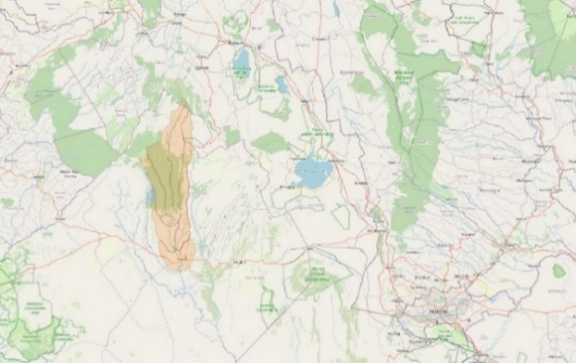The Enkare Narok river originates in the Mau Escarpment, about 60 kilometer North of Narok Town, Narok County, Kenya. This escarpment is a steep natural rampart that rises up to 3000 meter above sea level. The Mau is known for its rich Mau Forest and nutritious soil. In Figure 1, the watershed of the Enkare Narok river is colored orange and placed in its surroundings, ending in Narok Town. According to Hydrosheds, an open database offering various hydrographic data products like catchment boundaries, river networks, and lakes, the drawn watershed has a total area of 950 km2 (HydroSHEDS, 2024). The Enkare Narok river is a permanent river and flows downstream into the Ewaso Ngiro river, which enters Tanzania at Lake Natron.

Figure 1: Catchment area of Enkare Narok river (OpenStreetMap, 2024), (HydroSHEDS, 2024)

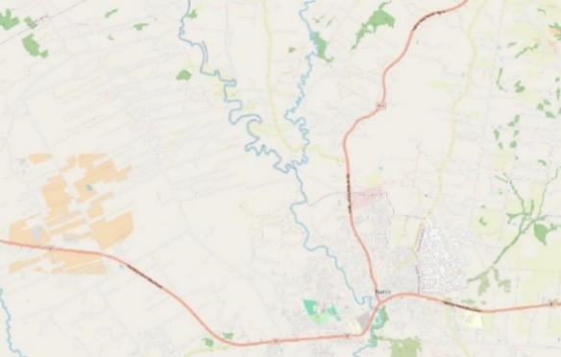Following Enkare Narok river from Narok Town upstream, you will come upon some junctions, splitting the river into smaller rivers. Figure 2 shows the first junction upstream from Narok Town. This study will follow the main river, the left one of the two waterways. However, water intake from this right waterway will need to be included in modelling the discharge along the river. In this eastern waterway, a bridge is found, which acts as a bottleneck for this water system. In case of high discharge, the surrounding area floods at this point. At the junction, also a water factory is located, tapping water from the river. The quantity is not known from this drinking water source. Looking at the figure, it is noticeable that the river meanders a lot, leading to many (sharp) turns in the waterway. Coming into town, the river follows a more straight path.

Figure 2: Enkare Narok river flow upstream from Narok Town (OpenStreetMap, 2024)

In Figure 3 it can be seen how the river runs as it flows into the Central Business District of Narok Town. Notice here that two drainage channels enter the river in the center of the town. Below the entry of the drainage channels, the river is crossed by two bridges. These two bridges are formed by first the B3 Kaplong-Narok-Maai Road and secondly a smaller nameless road next to it. Additionaly, a pedestrian 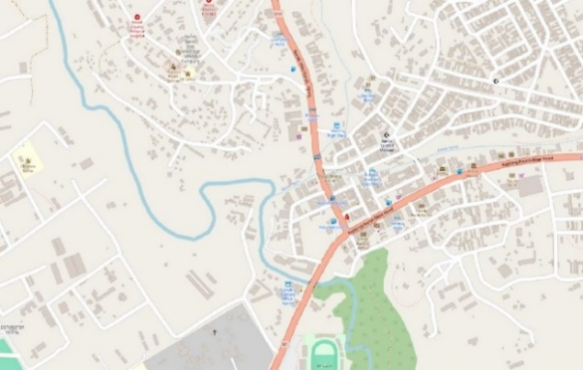bridge crosses the river next to the first bridge.

Figure 3: Enkare Narok river flow in Narok Town (OpenStreetMap)

# 1.2 Local authorities

In Narok County, Kenya, there are various authorities concerned with water management and flood risk. Some of these authorities are described in this paragraph.

## 1.2.1 Kenya Meteorological Department

As part of the Ministry of Environment and Forestry, the Kenya Meteorological Department (KMD) is responsible for the provision of meteorological and climatological services, to agriculture, forestry, water resources management, civil aviation and the private sector. The KMD is located in Nairobi, and has various smaller offices over the country. Their findings can be found on their website, are shared to certain organizations, and are shared by means of posts on X. They give out daily, 5-day, 7-day, monthly, and seasonal weather forecasts, as well as weather advisories and alerts. In Narok Town, a KMD office is located as well. Here, meteorological measurements are taken hourly, 24 hours a day. The KMD of Narok maintains a WhatsApp group, sharing rainfall forecasts, for Narok County. Many business owners, farmers, and residents are part of this WhatsApp group, which exceeds a number of 500 members. No flood alerts are given in this group, since this is highly variable spatially. Additional to the measurements of the KMD, also TAHMO stations are included in their analyses.

The major cause of the floods is considered to be heavy rainfall, during one of the rain periods. March until May is considered the period of long rains, when most of the average annual rainfall occurs. October until December is considered the period of short rains. Intensity of these rain periods vary per year, and are influenced by global phenomena such as El Niño. (Kahuthu, 2024) (Kenya Meteorological Department, 2024)

## 1.2.2 Water Resources Authority

Under the Water Act of 2016, the Water Resources Authority (WRA) was established, succeeding the Water Resources Management Authority (WRMA), which had been in existence since the Water Act of 2002. The mission of the WRA is “*to effectively regulate the management of water resources in partnership with stakehoders*”. The WRA offers a chart of services, which can be ordered by various stakeholders. Some services are free of charge, and some not. The Water Resources Authority collaborates with many internationally funded and organized projects as well. For example, the Horn of Africa-Groundwater for Resilience Project by the World Bank, the Blue Deal Programme of the Dutch Ministry of Foreign Affairs, and the TWENDE project (Water Resources Authority, 2024).

In Narok Town, an office of the WRA is located as well. The WRA is the authority of all public water systems such as the Enkare Narok river and therefore should be included and informed in any research done in the river. The WRA offered their knowledge on the flooding problems, and also lent some materials.

## 1.2.3 Maasai Mara University

Narok Town is the home of Maasai Mara University, which was founded in 2008, as Narok University College. The institute was chartered as a fully-fledged university on 2013. Over the last years, the university has grown a lot, and has also expanded their buildings. There are approximately 12,000 students, of whom most are undergraduates. The university has six schools, including the School of Natural Resources which corresponds most to the subject if this project. (Maasai Mara University, 2024)

The university appeared to be very much open for collaboration, and eager to share knowledge of the surroundings. They shared with us knowledge on the land type and land use of Narok County, as well as their ideas on the main causes of floodings in town and already taken measurements.

In the north of the county, the Mau forest functions as an important resource, as well as agriculture, with crops like carrots, cabbages, and potatoes. In the southern part, livestock is the most important resource. The southern part is a lot drier, and for a large part covered by the Maasai Mara National Park. Narok Town is located in a depression, which makes it very vulnerable to floods. Besides the location of the town, the contribution of the two sub catchments are also considered to be main causes of flooding, due to the large and very fast runoff of the drylands just above Narok Town. Although the river is very dangerous according to the university, it is not necessarily the main water source of floods.

The university emphasized the importance of empirical research and to include many stakeholders, like the National Forest Service and the National Disaster Management Authority. Flood risk and flood warnings for local areas are handled on a provincial level. There are also some measurements already taken by the County, namely the implementation of check dams and improved channels in town. (Mabwoga, 2024)

## 1.2.5 Findings and conclusions

For the implementation of a Flood Early Warning System the Kenya Meteorological Department and the Water Resources Authority are the main stakeholders which need to be informed and involved. Their knowledge of the river and weather system are highly valuable. Additionally, will their help be needed for the actual implementation of a Flood Early Warning System. Mainly the KMD is traditionally responsible for flood warnings. Maasai Mara University has contributed in knowledge, and offered insights in the local stakeholders in general. Involvement of an educational institute is not essential.

Conclusions on the main causes of the floods in Narok Town were not unanimous. Further study will be done on this subject based on literature research.

# 1.3 Local community

A round in town has been made to identify experiences with floods in town, the expected need of an early warning system, the warning time that would be appreciated, and to quantify damage caused by floods.

The flood prone area in Narok Town covers mainly the Central Business District. In this area almost no residents are found, it mainly includes small businesses such as car garages and small shops.

Some of the owners of small shops in the flood prone area stated that the only reaction on a flood warning would be to flee to higher grounds. No valuable possessions would be taken with them, besides possibly a motorcycle or car. The main motivation for this response is the lack of truly valuable material in the shop, and the experience that the water levels will not surpass knee-level. The main concern is loss of life. A corresponding warning time mentioned by these stakeholders is 30 minutes, up to 1 hour. Some of the interviewees stated as well that a formal system would not be necessary. A flood is preceded by rising water levels in the drainage systems and warning is given by shouting in the streets and by contacts living further upstream. This gives sufficient warning. Furthermore would it be important that warnings are accurate, and the meaning is well communicated. If a false warning is given, trust is easily lost.

Right at the river bank, two tree nurseries are located. One of the owners is interviewed on her experiences. She stated that being so close to the river bank, damage can be substantial. A flood can come very sudden, and water will flow from many directions towards their property. A warning could be very valuable, with an emphasis on the accuracy of this warning. A corresponding warning time would be 2 hours, up to 1 day.

Another response given by various interviewees is a concern about the new check dams that are constructed just north of town. In 2024, the long rains were extremely intensive, and a fear was spread that one of the dams could break.

# 1.4 Literature study

A literature study was conducted, mostly appending to the found results of other sources. The findings are structured per subject. Firstly, the sub catchments draining into the channels that run through town are further illustrated. Subsequently, the influence of heavy rainfall upstream and deforestation is discussed. Existing warning methods are elaborated upon in Paragraphs 1.4.4. In Paragraph 1.4.5, studies on local critical precipitation amounts for flood risk in Narok Town are discussed.

## 1.4.1 Esamburmbur and Kakia catchments

As mentioned above, two major drainage channels run through town and drain into the Enkare Narok river. These two channels are formed by drainage water coming from the Esamburmbur and Kakia catchments, northeast from Narok Town. The catchments cover an area of 15 km2 and 30 km2 respectively. The channels are considered to be seasonal rivers, only containing water during rain seasons. (Mossel, 2020) Upon entering the central business district of Narok Town, both waterways are contained within concrete channel beds. These channels streamline the water flowing through the center of town towards the Enkare Narok river. The channels are crossed by multiple bridges.

The two sub catchments are dry lands, with low infiltration capacities. This leads to high runoff coefficients and therefore fast and high discharge in the streams. In case of intensive rainfall, flash floods can form within the streams, causing the contribution of these two streams to the main river to be significant, increasing the risk of flooding. Over time, land use and land cover shifted towards increased agricultual and urban development in the Kakia and Esamburmbur subcatchments. This shift further reduced the soil's infiltration rate and hydraulic conductivity, resulting in more runoff. (Etienne Umukiza J. M., 2021)

In a study to implement flood risk reducing measures, it was concluded that the Kakia channel had irregular height and width due to constructions that were placed throughout the canal, extending from upstream to downstream. Regarding the Esamburmbur channel, it was noted that the bridge's location caused the channel to narrow downstream and the banks to get lower. The channel's free flow is impacted by the changes in geometry, which could result in overflow in the channel's narrower section. The respective total lengths for Kakia and Esamburmbur were determined to be 1420 m and 360 m. (Etienne Umukiza J. M., 2022)

## 1.4.2 Deforestation and heavy rainfall in the mau forest

In the Rift Valley in Kenya, the Mau Forest is located, north of Narok Town. This forest complex is considered the largest indigenous montane forest in East Africa, with an area of 273,300 hectares. The region also forms the largest drainage basin in Kenya, and is the source of multiple rivers, among which the Enkare Narok river, later on draining to the Southern Ewaso Ngiro river. (Wikipedia, 2024)

In Kenya, land is a very important resource, getting more valuable over time. The Mau Forest, which has very rich soil and rich wood resources, has been subject to deforestation for logging, and for area clearance for settlement and for agriculture. This process is not beneficial for the risk of floods as trees absorb large amounts of water. With deforestation, less water is absorbed, thus increasing the runoff and discharge in the Enkare-Narok river, increasing the risk of flooding. The severity and frequency of floodings increases because of this change in land use upstream of the Enkare-Narok river. Due to global warming, the intensity of rainfall has increased, further raising the risk of floods.

## 1.4.3 Existing LOCAL warning systems

In Narok County, stakeholders  receive flood early warning information from various sources and types. This early warning information includes weather forecasts, inundation maps, advisories and alerts, and indigenous flood information. In terms of available knowledge, is prediction data from the Kenya Meteorological Department the major source, accounting for almost 50% of the data, indigenous and local knowledge follow with 17%. In terms of flood early warning information, the sources include Kenya Meteorological Department, Water Resources Authority, National Disaster Operation Centre, County Commission’s office, County Government and Red Cross. Kenya Meteorological is the major source of flood early warning information followed by Water Resources Authority. (World Bank, 2021)

Inhabitants of Narok County receive the warnings through radio (57%), TV (17%), social media (11%), friends (9%) and social gatherings (6%). WhatsApp is one of the channels used to communicate information about impending flooding to other county-relevant government entities. The Kenya Red Cross, the county disaster management unit, and other pertinent county officials also spread the early warning information to the community. Community meetings (Barazas), which are arranged by chiefs and assistant chiefs, are also a noteworthy additional means by which flood information is communicated in Narok County.

Key informant interviews show that only 67% of relevant institutions and department received flood early warning information for March-April-May 2018 flood events. This indicates the need for an effective and efficient communication strategy that aims on improving the knowledge and building support for flood early warning communication. Based on the stakeholders’ needs, timely communication (more than 7 days before flood occurrence) of flood early warning information will help in mitigating flood impacts since more time will be available to take flood early actions such as relocation to higher grounds. (World Bank, 2021)

## 1.4.4 Flood Prone Area in Narok Town

It was already found that especially the Central Business District of Narok was prone to floods. This is the lowest part of town and also the junction of the main river and the two channels. A study by Dorius Le Poole, for his MSc thesis at TU Delft, concluded on the main bottleneck, the flood point and estimated flooded areas for different flash floods. He concluded that a bridge was the main bottleneck, due to the narrowing in the river bed and a limited water level depth. Approximately 400 meters upstream of the bridge, the channels drain to the river. Just after this junction, the flood point was identified. At this point, the banks are the lowest and high water levels are reached due to the combination of both the addition of the discharge of the channels and the backwater curve caused by the bridge. Le Poole modelled the occurrence of flash floods in this small river reach by using SFINCS, for different peak discharges. In his model, different time series of discharge were simulated. Firstly, constant discharges, ranging from 30 to 160 m3/s for a period of 4 hours were used as input, not resulting in floods. Subsequently, a flash flood was simulated, starting at a base river discharge of 30 m3/s, going up and down in steps of 30 minutes over a total period of 4 hours, to either 170 m3/s, 180 m3/s, 190 m3/s, 200 m3/s, 210 m3/s, 220 m3/s, 230 m3/s or 420 m3/s. All scenarios led to flooding in town. The results are shown below, in Figure 4. The blue parts indicate land overflow, with a grid of 30 by 30 meter. These discharges were selected, since Le Poole determined the maximum discharge of the natural bank flow conditions upstream of his river reach to be 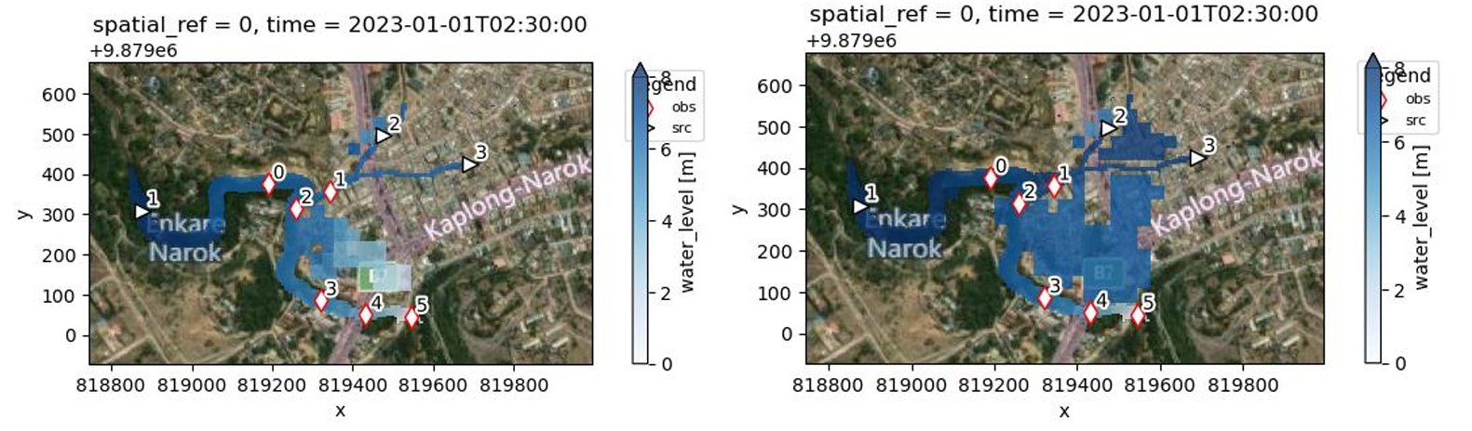230 m3/s, and downstream of his river reach 420 m3/s. (Poole, 2024)

Figure 4: Simulated floodplains in Narok Town. Discharge input is given at the black arrows 1, 2, and 3, for the river and the two channels. The flood point is concluded to be at red point 2, and the bottleneck at point 4. (Poole, 2024)

## 1.4.5 Critical precipitation amounts

By comparing historical data on rainfall measurements, to recorded flood events, conclusions can be drawn on critical precipitation amounts that cause flood risk.

A statistical flood frequency analysis in 2019, analysed past major flood events by identifying rainfall return periods on these days. In January 1993, a daily rainfall of 81.7 mm, corresponding to a return period of 6 years, led to a major flood in town. In March 2013, April 2013, and April 2015, daily rainfall amounts with return periods of 1 year, of respectively 33.6 mm, 24.4 mm and 33.2 mm were measured, which also led to flood events. Additionally, it was concluded that flood risk not only depends on daily rainfall on the day itself, but is also influenced by the cumulative rainfall over the three days before. (Eva Audrey Yessito Houessou-Dossou, 2019)

A study by TEMBO on Narok County states that accumulated rainfall of 20 mm in 24 hours causes no risk for flooding. Rainfall amounts between 20 and 50 mm are considered to have a medium risk, while rainfall amount exceeding 50 mm are considered to indicate a high flood risk. (TEMBO Africa, 2024)

# 1.5 Media sources

In local media, past flood events have been reported upon, stating damage, casualties and the causes. Additionally, videos of flash floods flowing through town can be found on YouTube. Historical flood events that are found in media sources, are listed in Paragraph 1.5.1. Some risk-reducing measures have been made in the Kakia and Esamburmbur catchments, just north of Narok Town, which are also reported in local media. This is described in Paragraph 1.5.2.

## 1.5.1 Past Flood Events

Past flood events were found on the following dates: January 20th 1993, March 30th 2013, April 18th 2013, April 28th 2015, May 6th 2015, January 26th 2020, April 3rd 2023 and December 6th 2023. This list of events is combined of multiple sources. In April/May 2015 exact dates are not found to be conclusive, this is due to high daily rainfall amounts for many days in a row, leading to multiple floods in this period. (Eva Audrey Yessito Houessou-Dossou, 2019) (World Bank, 2021) (Sayagie, 2015) (Citizen TV Kenya, 2020) (Nation, 2023) (NTV Team, 2023)

## 1.5.2 Current Flood risk-reducing measures

Two check dams have been constructed near Narok town to reduce the frequent flooding in the town, Mukuru mbili and Oloipito Ilmasharian dam. A check dam is a construction with the goal to reduce the flow velocity and soil erosion, while also contributing to groundwater recharge. Locals are scared that the check dams will overflow during heavy rainfall or even worse, break. Several mitigation measures have been carried out to prevent failure. (Kirui, 2024)

The construction of Osonini Check dam is ongoing while five more check dams have been proposed along rivers Esampurmpur and Kakiya to reduce floods in Narok. (National Water Harvesting & Storage Authority, 2024)

# 1.6 Conclusion

A short answer is provided on the questions defined in the “Manual for the implementation of a flood early warning system in small urban areas in Africa”. This functions as a summary of information retrieved by different sources and already described in this Chapter.

* *Where do the floodings occur?*

Floodings occur in the centre of Narok Town, just north of the bridge and south of the junction with the channels, on the east side of the river. The flood plain covers an estimated area of 18000 m2 approximately.

* *What is the impact of the floodings?*

Narok Town has experienced flash floods approximately every 5 years over the last decades. An exact number of casualties is not known, but is assumed to be 1 to 5 persons. Additionally, a lot of cattle has been lost during floods. Damage includes damage to properties, household contents, valuables in shops, damage to infrastructure, and loss of market goods. In most of the region, water levels will rise to knee-height. Therefore, the damage mentioned is limited. However, flow velocities of the floods can get rather high, sweeping away cattle and property.

* *What is the frequency of the floodings?*

Floodings can either occur during the ‘short rains’ season, or during the ‘long rains’ season. Together, this period accounts for a period of about 5 months. Historically, major flood events occurred in Narok Town every 5 years. In Narok County, floods occur yearly.

* *What are the conditions in which floodings occur? (e.g. heavy rains?)*

Floods occur in Narok Town due to heavy rainfall north of the town. Two areas are considered major contributions; the Mau Forest, and a dryland area of approximately 45 km2, right north of town. High rainfall amounts in these two regions can indicate flood risk for Narok Town. Additionally, high daily rainfall over consecutive days increases flood risk.

* *Are there any external factors that can influence the occurrence of floods, e.g. side channels or the presence of dams and levees?*

Two channels drain into the Enkare Narok river right in town. These channels are have two seasonal rivers as supply, draining rainfall of catchments of 15 and 30 km2. Their discharge is a substantial contributor to the discharge in the river. Further upstream, about 6 kilometres upstream from the bridge, another side stream contributes to the river. At this same junction, a water factory is located, tapping water from the river to produce drinking water. The quantity is unknown.

Upstream in the two channels that flow through town, check dams have been constructed. These structures collect water temporarily, to decrease flow velocity and increase ground infiltration. These dams could break at high discharges, which would cause major flash floods in the direction of Narok Town. This flood risk would not be included in the Flood Early Warning System as proposed in this project, which will only measure water levels in the main river, and not in these channels.

* *What are the main stakeholders concerning water management and rainfall predictions?*

The main stakeholder is the Kenya Meteorological Department, which is traditionally responsible for flood warnings and already maintains multiple (simple) warning systems in Narok County. Secondly, the Water Resources Authority needs to be included in the design steps needed to implement a FEWS. For this, measurements need to be made in the river, which the WRA would like to be aware of.

* *Have any measures been taken to prevent the floods and what is their effectiveness?*

For flash floods in the two channels flowing through town, multiple prevention measures have been taken. Firstly, the water ways have been channelled in concrete beds, upon entering the centre of town. In the last decade, these channels have been further deepened and widened to give more space to the water. Upstream in these same channels, check dams have been constructed, which aim to slow down the water flow and a the same time increase groundwater infiltration.

* *Do local residents already have a sort of warning system in place (e.g. through WhatsApp) and how does this function?*

At the moment, a flood warning is given to residents in various ways. First of all, floods are expected when the water levels rise quickly in the drainage channels in town. Shouting through the streets will follow when a flash flood in the main channels is identified. This will warn people and cause them to run from the lowest parts of town to higher grounds. Additionally, personal contacts in upstream areas give warnings to residents in town, when high rainfall amounts are experienced. The KMD maintains a communication channel for rainfall predictions via WhatsApp, where forecasts are shared and different stakeholders can communicate about water levels and flood risk.

With all findings that are described in this Chapter considered, the need for a Flood Early Warning System is considered valuable. The certainty and warning time of the warning system are important characteristics to keep in mind, to design a truly valuable system.

2. Boundaries of the river reach and spatial analysis

The Flood Early Warning System will be designed based on a river reach, that is limited by the bottleneck in town at the downstream end, and river flow gauge at the upstream end. This river reach will be mapped and modelled, which is described in Chapters 3, 4, and 5. The boundaries are determined in this chapter.

# 2.1 Identification of the flood point

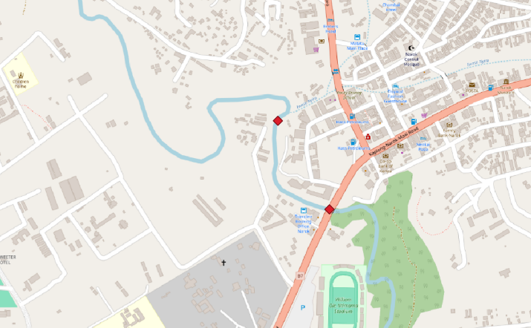The flood point is identified just downstream of the junction of the Enkare Narok river and a drainage channel, in the centre of Narok Town. At this point, water will flow over the river bank first, causing the start of the flood. The capacity of the river is determined by the bridge, another 400 meters downstream. The bridge is therefore the bottleneck of the water system, due to the narrowing of the river banks and a limited water level depth due to the bridge deck. This bottleneck will cause a backwater curve, which is noticed by increasing water levels in the upstream direction from that point, up until the flood point. These points are determined by Dorius Le Poole in his MSc thesis on “Rapid hydraulic assessment tool for river floods using hydraulic geometry relations in data scarce areas”. His study has functioned as a starting point for this study. The two identified points are illustrated in Figure 5. The bridge is considered the downstream boundary of the river reach, since it is assumed that if the capacity at this point is exceeded, a flood will occur.

1

2

Figure 5: Identified flood point (1) and bottleneck (2) of the water system in Narok Town, of which point 2 will be the downstream boundary (Poole, 2024)

# 2.2 Identification of the gauge placement

To determine a location for the water level gauge, firstly, rough estimations were made on the reachability of the river going upstream. Multiple points were identified where the river could be reached, after which the steps below were followed.

## 2.2.1 Warning time

To determine an adequate as well as feasible warning time, mostly information gathered in interviews is used. Additionally, literature has been consulted on general findings in the relation of warning time and damage reduction.

### Interactions in town

As described in Paragraph 1.3, interviewed stakeholders in town, mostly small business owners, considered loss of life as their main concern when it comes to floods. A warning would therefore be appreciated, in order to be able to flee. Described actions included taking motorcycles and/or cars, or just running to higher grounds. Considering the flood plain has proven to be quite small in former flood events, the required time to flee is limited to approximately 30 minutes at its maximum; most interviewees mentioned a time of a couple of minutes. If more time was given, some business owners that are closer to the river banks would evacuate all their belongings, but others would still leave their business behind.

### Input of students of Maasai Mara University

To further dive into the subject of warning time related to different stakeholders, an interactive session was held at the Maasai Mara University. This session was attended by 15-20 students of the faculty Natural Resources, of which most were enrolled in the Urban Planning programme. Four stakeholders were given: visitors, residents, shop owners and farmers. For every stakeholder, the possible actions were asked for different warning times, e.g. 5 minutes, 30 minutes, 60 minutes, 120 minutes, or 1 day. The results are included in Appendix A. The main findings are described here.

* For visitors, it was noticed that unfamiliarity with the surrounding, and the warning system, are delaying factors. First, the right contacts will need to be made, in order to receive good instructions. 30 minutes will suffice to run, 60 minutes will be required in order to understand the impact. 1 day is required for visitors to return to their homes and to dodge the flood event.
* For residents, the main concerns included the ability to take personal belongings, and the ability to warn family and neighbours. It was concluded that in 5 minutes, you can only save yourself and possibly an ID and/or mobile phone. In 30 minutes, essential items can be taken and family and neighbours can be warned quickly. In 60 minutes, you will be able to reach more friends and family and possibly pack an emergency kit, suited for a longer time. In a day, a safer living place could be identified and reached. In conclusion, a required warning time of 120 minutes was stated, since this would give ability to inform and relocate everyone, including essential personal belongings.
* For farmers, main concerns included machinery, relocation of livestock, and post flood recovery. 30 minutes was considered sufficient to evacuate most of the livestock and run themselves. With more time, all valuable belongings and all livestock could be safely relocated. If a day is given, possibly even the fields can be harvested to save the goods. In conclusion, a required warning time of 1 day was stated.
* For shop owners, main concerns include notifying customers, and saving their stock. For shop owners, the reliability of the warning was also stated multiple times, since this will influence the actions of this stakeholder. In 5 minutes, one could run. In 30 or 60 minutes, one could notify all customers and relocate some of the stock to higher shelves. In more time, one could relocate all properties to a saver place, but there is doubt on whether this would actually happen. In conclusion, a required warning time of 1 hour was given.

### Findings in literature

Not many conclusions are drawn in former studies that determine a perfect warning time. As is already described in the manual, a warning time will be a trade-off between accuracy of the warning, and larger timeframes.

A study by Schröter et al. (2008), emphasizes the need of a proper cost-benefit analysis before implementing a Flood Early Warning System. This analysis can be used to determine the utility of a system, as well as the decisions that need to be made when warnings are issued. Damage reduction is found to range between a few percent points to 35 percent, of average annual flood damages. Loss of life is difficult to include in these economic terms. Schröter et al. conducted two case studies for small basins, one in Austria and one in Spain. In these studies, a damage reduction of up to 60% can be reached for a warning time of 12 hours, and a reduction of 20% can be achieved for a time of 1 hour. For both basins, the case of a flash flood is considered. (David Rogers, 2011)

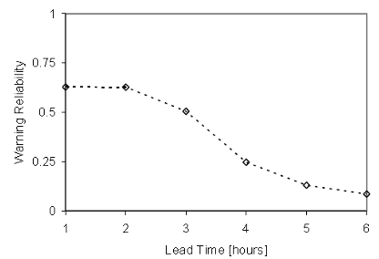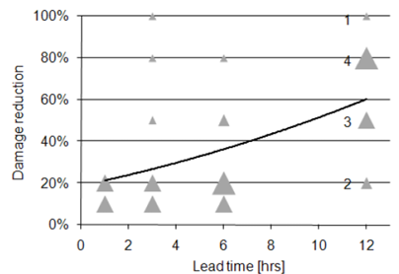

Figure 6: Warning reliability and damage reduction as functions of warning lead time (David Rogers, 2011)

A study on flood early warning communication in Narok County, determined an optimal warning time for the county. In this report, weather forecasts of the Kenya Meteorological Department are given as main input for flood early warning models. It is stated that a preferred timing for flood early warning information should be more than 7 days, in order for the strategy to be adequately performed. (World Bank, 2021)

### Processing time

When a warning is issued, it is of importance that the reliability of this warning is checked, before an actual warning will go out. The detailed process is not yet determined, but an estimation of 15 minutes will be added to the warning time.

### Conclusion

In the flood plain of Narok Town, mostly shop owners are found, as well as visitors and other pedestrians. For these stakeholders, the main concern will be to collect essential items, warn people in their surroundings, and evacuate the low-lying areas. It is concluded that a warning time of approximately 1 hour would be sufficient. The reliability of the warning is of high importance, and will influence the actions taken by everyone who is involved. Longer required warning times were found in literature, however these are not feasible in the warning system that is proposed in this project. To account for the processing time, an additional 15 minutes is added to the warning time.

## 2.2.2 Flow velocity of a (flash) flood

In order to estimate the flow velocity of a flash flood in the Enkare Narok river, the range as given in the manual is used. It is stated that a flash flood, in Kenya, ranges from 0.05 to 4 [m/s]. To determine a first estimate of the upper boundary of the river reach, the upper boundary of this range, namely 4 [m/s], will be assumed.

## 2.2.3 Conclusion

An aim to be able to detect a flood risk 1 hour and 15 minutes before the flood will hit town was determined. A flash flood is estimated to have a velocity of 4 meters per second, which is equal to 14.4 kilometres per hour. This concludes in a minimal distance of 18 kilometres upstream from the bridge in town, as an appropriate location for the gauge placement. Combined with the first identification of reachable locations, a spot is located which is 16.5 kilometres upstream of the bridge. This does not satisfy the determined length of 18 kilometres, but is is still regarded the best possible option. The point will be the upper boundary of the river reach.

# 2.3 Spatial analysis of the river reach and corresponding catchment

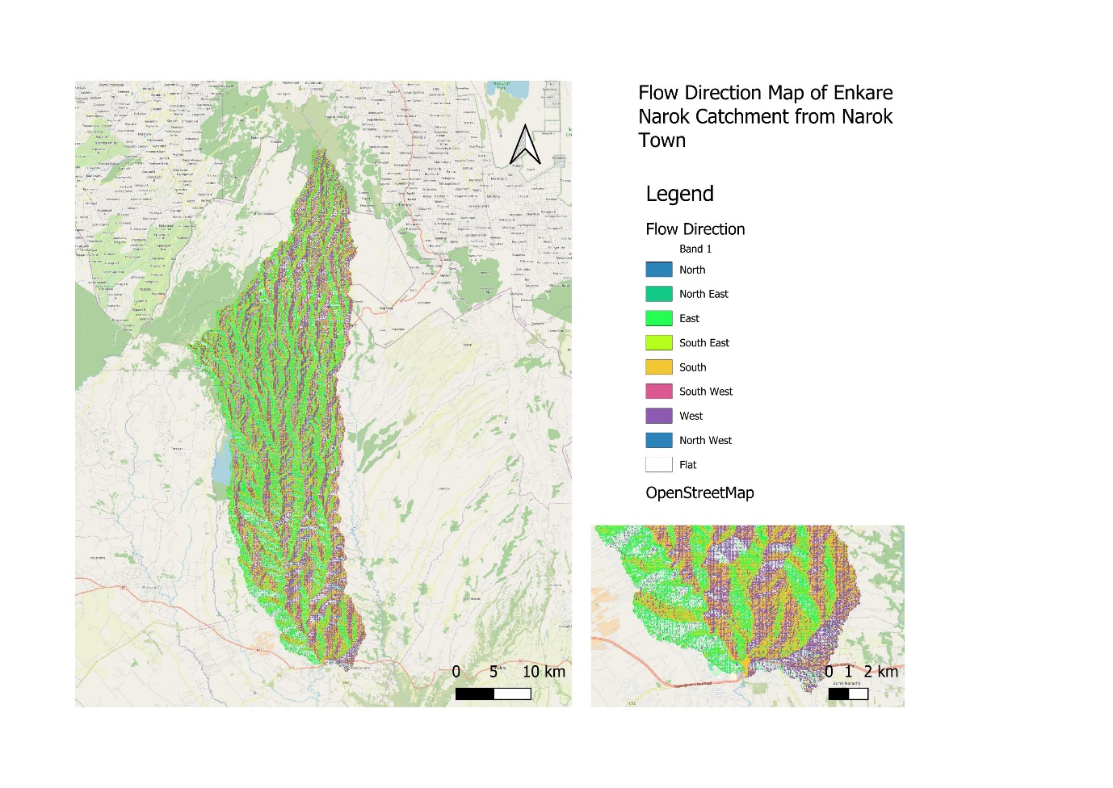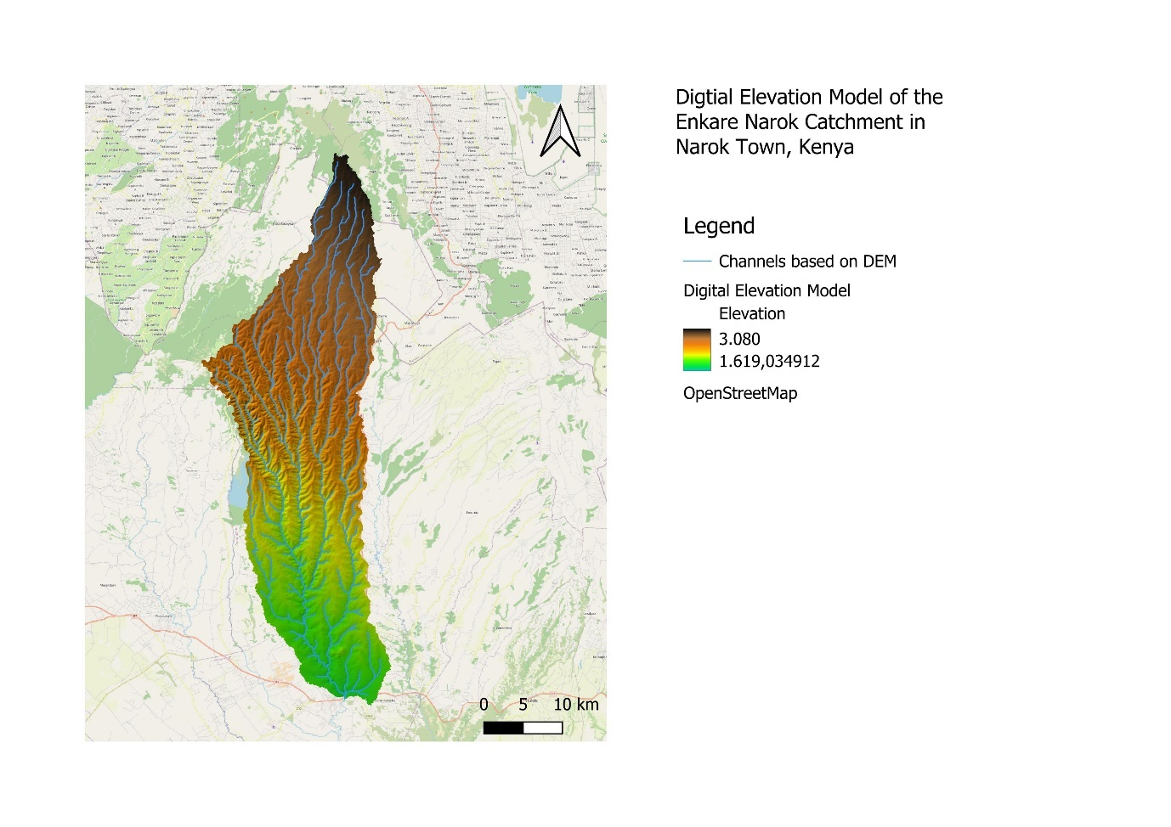A digital elevation map is created, based on data retrieved from the Shuttle Radar Topography Mission (SRTM) of NASA. (NASA's Earth Observing Centre, 2024) Based on this elevation data, water streams catchments are delineated for the Narok region. Figure 7 shows the elevation map, of the catchment of the Enkare Narok river, established from the bridge in town. Figure 8 shows the flow direction of water runoff in the catchment. The maps are drawn with WGS 84 / UTM zone 37S as coordinate reference system.

Figure 7: Digital Elevation Model, with corresponding legend, of the catchment, created in QGIS

Figure 8: Flow direction map, with corresponding legend, of the catchment, created in QGIS

## 2.3.1 (sub) catchments of the river reach

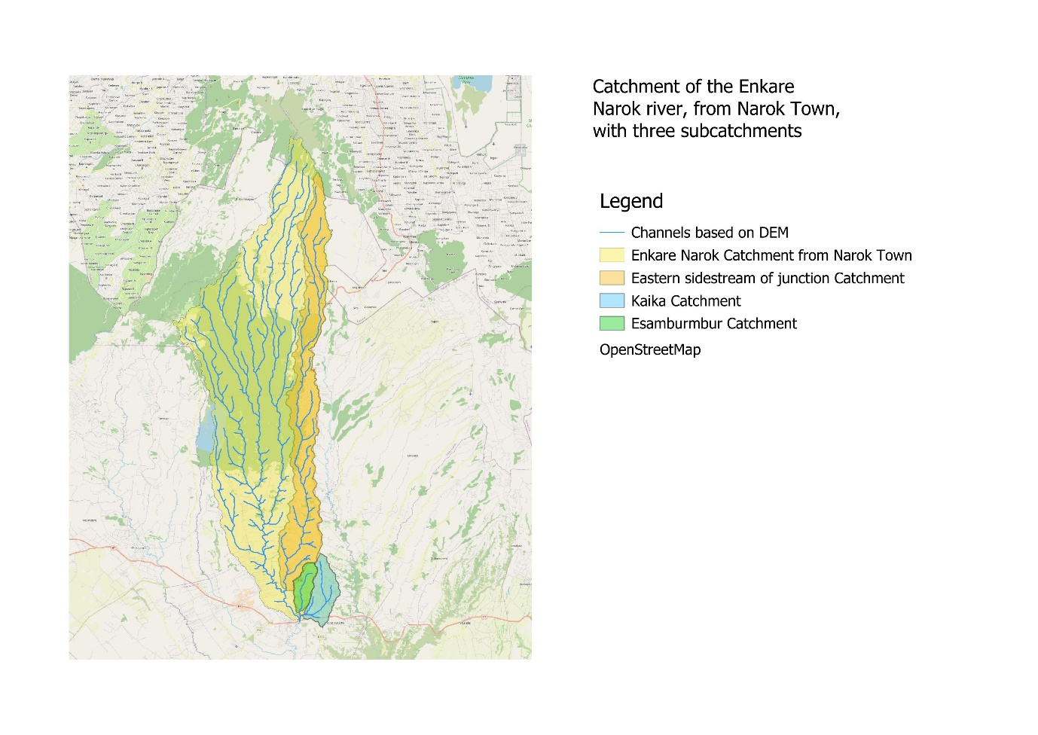Figure 9 shows the delineated streams, and the catchments of three sub catchments: the side stream that connects to the river approximately 6 kilometres upstream, and the two sub catchments belonging to the drainage channels that flow through town from the east.

Figure 9: Catchment delineation map, with corresponding legend, created in QGIS

The corresponding areas are:

* Total catchment (yellow area): 895,8 km2
* Easter side stream catchment (orange area): 199,4 km2
* Esamburmbur catchment (green area): 15,2 km2
* Kakia catchment (blue area): 29,3 km2
* Esamburmbur and Kakia catchments together: 44,5 km2

The areas are determined based on the delineations in QGIS. These are drawn based on the elevation data and the corresponding natural flow. The actual water streams are slightly different, due to erosion and/or human interference.

3. Map the river

Using the obtained knowledge about the Flash Floods occurring in Narok Town, it is time to determine useful cross sections in order to map the river for modelling. Our considerations and selection of cross profiles is discussed in paragraph 3.1 and 3.2. The measurement execution is then discussed the following paragraphs. Following from this chapter is all the required data for the modelling.

# 3.1 Exploration of cross-sections

The first step in exploring the cross-sections is to determine how far upstream one has to measure. This was done based on the desired warning time and the estimated wave celerity. The ideal warning time required would be 2 hours, with an estimated wave celerity of 4 [m/s] this would mean that the sensor would have to be placed 28 kilometres upstream. This however did not seem possible as no roads reached that far. The most upstream cross-section possible was taken 16 km upstream from the bridge.

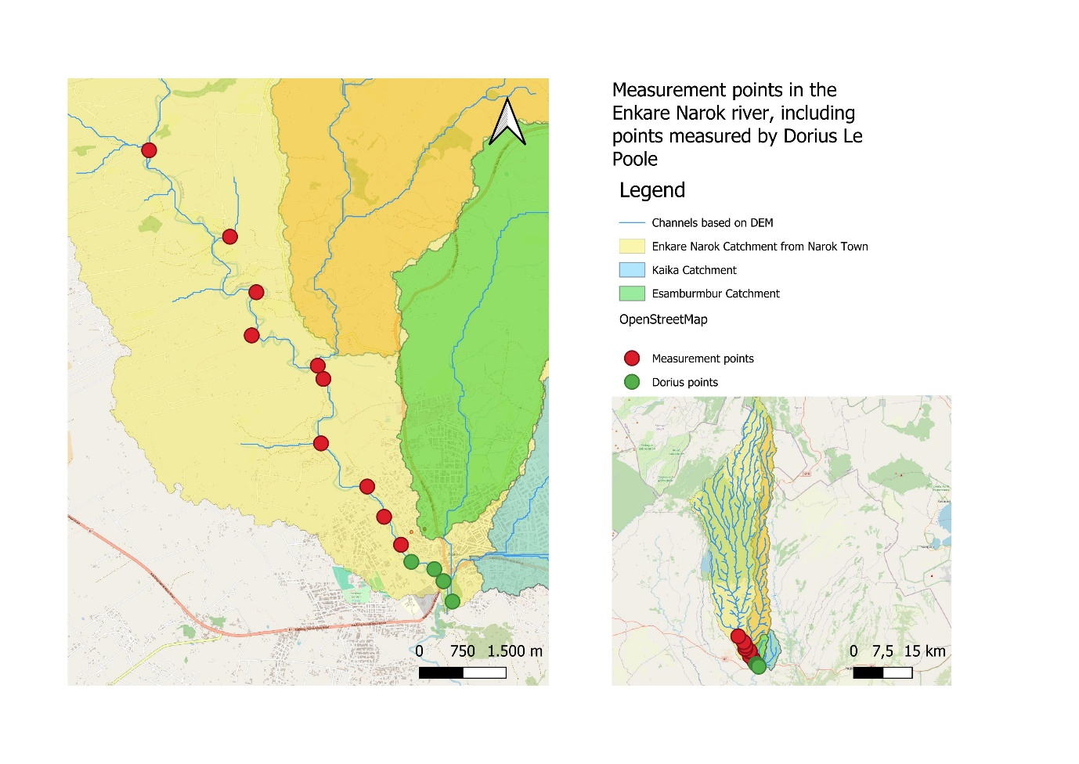The number of cross sections that one should measure strongly depends on the accessibility of the river. The chosen approach in this project was to check on Google Earth how much locations along the river seemed accessible. For this case study 10 cross-sections seemed to be possible over a length of 16 kilometres. Thereby an additional cross-section was taken at the tributary. The explored cross-sections are shown below in figure 10. The exact number of cross-sections needed will be decided in chapter 5 with a sensitivity analysis of the model.

Figure 10: Measurement points (red) in the river, starting at the bridge in town going upstream to a distance of 16.5 kilometres, shown together with delineated water streams and corresponding (sub) catchments, created in QGIS

Next the measurements that should be done were determined. The following has to be measured:

* Cross-Section of bankfull state
* Velocity Profile
* Waterlevel
* Slope

Based on the needed measurements and the amount cross sections a planning was made. At most, two cross-sections can be measured per day.

# 3.2 Incorporation of Junctions

In the river reach, two junctions are found. For both junctions, a different methodology is used to incorporate the additional water flow.

## 3.2.1 Eastern side stream at 6 km upstream

At approximately six kilometres upstream of the bridge, the water stream splits in two. The western stream is considered the main branch and also has a larger water flow. The eastern stream will not be modelled, but the discharge contribution will be assumed based on a discharge ratio, as described in the manual.

Measurements have been made in the two streams to determine the discharge at a certain day. The discharge was relatively low, and therefore possible to measure. The discharge is based on the average flow velocity ($v$) and the flow area ($A$), which is measured with a GPS system. The measurement methodology is described in this Chapter, Paragraphs 3.3, 3.4, and 3.5. The discharges (), in [m3/s], are compared and a ratio is determined. The same ratio is assumed for the case of high discharge in the river, which is modelled in Chapter 5. The measured discharge in the western stream (main river) is 1.39776 [m3/s]. The discharge in the eastern stream is 0.35283 [m3/s]. This gives a ratio of 0.798/0.202 respectively.

A discharge ratio can also be determined based on areas of the sub catchments. For the eastern side stream, an area of 199,4 km2 is found. The area of the total catchment is 895,8 km2, and the area of the catchment of the western side stream is 631.2 km2. This means that 22.3% of the total discharge comes from the eastern side stream. At the junction, this relates to a discharge ratio between the western and eastern streams of 0.684/0.316 respectively. In this method, it is assumed that rainfall is equally distributed over the total catchment, and runoff coefficients are equal as well. In this case, with the majority of the Mau Forest laying in the western catchment, this will probably be a light over estimation of the discharge coming from the eastern stream.

It is decided to use an average of both methods, concluding in a discharge ratio of 0.74/0.26 between the main river and the eastern side stream, for both low and high discharges.

### Narok water treatment plant

Just a couple meters downstream from the junction, a water treatment plant extracts water from the Enkare Narok river. Narok water and Sewerage Services Company Limited (NARWASSCO) is a public company, with as main objective to supply clean water and sewerage service to Narok Town, Ololulunga Town and its environments. The quantity of water extraction is unknown. This water loss is not included in further calculations (Narok County Government, 2024).

## 3.2.2 Drainage channel in town

The discharge of the channels, combined with that of the main river, contributes to the overall discharge during a flash flood. This discharge is based on literature, as already research had been done on the contribution of the channels to the main system, which is considered more accurate than the method above. Overflow of the channels will be disregarded since the focus is on potential flooding from the main river.

Measurements of the dimensions of the Kakia and Esamburmbur channel have already been taken by a study from the Pan African University using RTK equipment. This study improves the design of the channels based on estimates of future peak discharges, considering four future Land Use and Land Cover (LULC) scenarios in the sub catchments. Scenario 1 assumes a significant increase in urbanization and agricultural activities leading to drastic reduction of forest area. Scenario 2 projects moderate urbanization, a reduction in agriculture and an increase in pastureland and reforestation. Scenario 3 focuses on major urban expansion with little focus on forest preservation. Scenario 4 proposes a balanced distribution, assuming moderate land-use changes across all sectors. (Etienne Umukiza J. M., 2022)

Calibration of an advanced hydrological model for a small and ungauged basin as this one is difficult as observed flow data is scarce. Therefore Umukiza uses the Event-Based Approach for the Small and Ungauged Basins rainfall-runoff model (EBA4SUB). The inputs data needed by the model are the Digital Elevation Model (DEM) of the investigated catchments, the LULC data and the rainfall data. Based on this, the evaluated values related to peak discharges for 50 and 100 years return periods for the different projected scenarios are summarized in Table 1.

Table 1: Peak discharges in the water streams of the Kakia and Esamburmbur catchments for 50 and 100 years return period (Etienne Umukiza J. M., 2022)

|  |  |  |  |  |
| --- | --- | --- | --- | --- |
|  | Kakia | | Esamburmbur | |
| LULC | Tr50  *[m3/s]* | Tr100  *[m3/s]* | Tr50  *[m3/s]* | Tr100  *[m3/s]* |
| 2019 | 130.3 | 164.1 | 75.1 | 94.2 |
| Scenario 1 | 154.2 | 191.1 | 88.9 | 110.1 |
| Scenario 2 | 121.4 | 154 | 70.8 | 89 |
| Scenario 3 | 172.2 | 210.4 | 100.6 | 121.8 |
| Scenario 4 | 145.3 | 181 | 83.4 | 104.2 |

According to Umikaza (2019) the highway bridge over the Esamburmbur channel, located 295 metres from the upstream, may contribute to overflow. This therefore determines the maximum capacity through the channel. With the current geometric properties represented at that position the peak discharge estimated in scenario 4 with 10 years return period, is 52.18 [m3/s]. With the current geometry of the Kakia channel the capacity is 144.2 [m3/s], it can convey peak flow estimated in scenarios 2 and 2019 at 50 years return periods (Paper improving drainage systems). (Etienne Umukiza J. M., 2022) These two estimates will be taken as additional discharge input in case of a flash flood, at the junction in town. The two channels are combined just before draining into the Enkare Narok river.

# 3.3 GPS system and background

The of Ardusimple was determined to be a viable setup for the intended use, as they are cheap, precise and rely on open source software. The setup consisted of:

* Two simpleRTK2B Pro receiver boards;
* Two Serial data logger modules;
* An U-Blox GNSS Multiband antenna ANN-MB-00;
* A Budget Survey GNSS Multiband antenna (IP66).

The system was build based on the principle of Post Processing Kinematic (PPK). This is the approach where all received satellite information is stored locally. By using post processing software, the location of the Base station and Rover can be calculated. The main advantage of this system is that the Base station and Rover do not need a direct line of sight between each other as most systems need. One is therefore able to place the Base station in a secure location with a clear view of the sky. The Base station was placed as illustrated in Figure 11below.

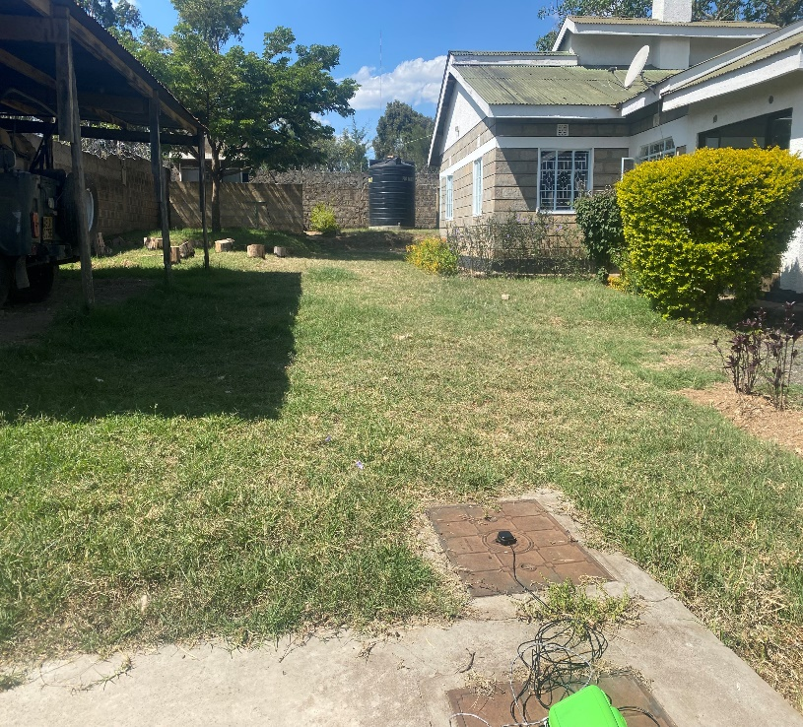

Figure 11: Base Placement

Note that the Base station was also placed on a steel cover. This has two reasons with the first being that this placement limits the possibility of accidental movements as the antenna is equipped with a magnet. Movements of the Base station during measurements mean that all recorded data is unsuitable for data processing. Unfortunately, our project team suffered from this once.

The second reason for placing the Base station on a steel cover to achieve maximum gain towards the sky (Ardusimple, 2024). This is crucial in achieving centimetre level positioning.

# Preparing a measurement day

In preparation of the measurement days, our first step was contacting the Water Resource Authority and present them our measurement plan. An important aspect of this was presenting the locations and timeline as showcased below in Figure 12. From this we gained the necessary permissions to execute the cross sectional measurements.

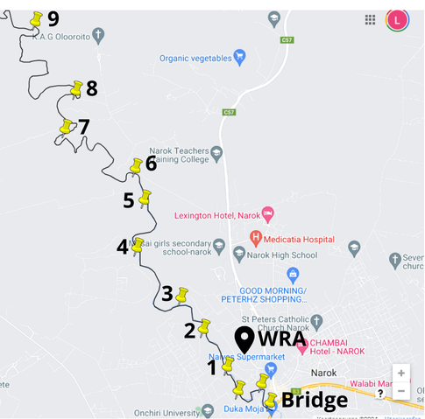

Figure 12: Measurement plan visualisation

Following from Chapter 1.2 we had already acquainted with the Kenya Meteorological Department (KMD). As the KMD Officer Josiah was very interested in the project at hand, he provided us with an enormous amount of support. In his own time, Josiah acted as chauffeur during measurement days in his 4x4 vehicle depicted in Figure 13 below. The required equipment was already gathered in the Netherlands. Familiarity with the functioning was obtained by executing trial measurements in our backyard.

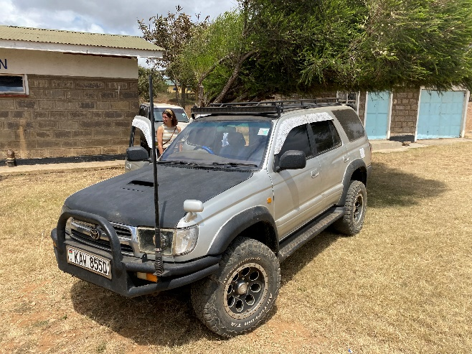

Figure 13: Off-road vehicle

# 3.5 Execution of a measurement

Over the course of the ten week project, ten cross sections were taken to serve as an input for the modelling. As the project team encountered several problems, some of the measurements had to be executed again. Resulting from these in-field experiences, the step by step manual was build. Following this guide should therefore result into usable data to proceed with the modelling approach. But always be prepared that fieldwork never works out the way as you expect, just like in Figure 14 where a herd of cows interfered with our field measurement. It is therefore important to always keep an open mind and look at what data and/or options there are given the circumstances one is working with. Be creative, finding or obtaining flawless data is near impossible, learn how to work with the uncertainties.

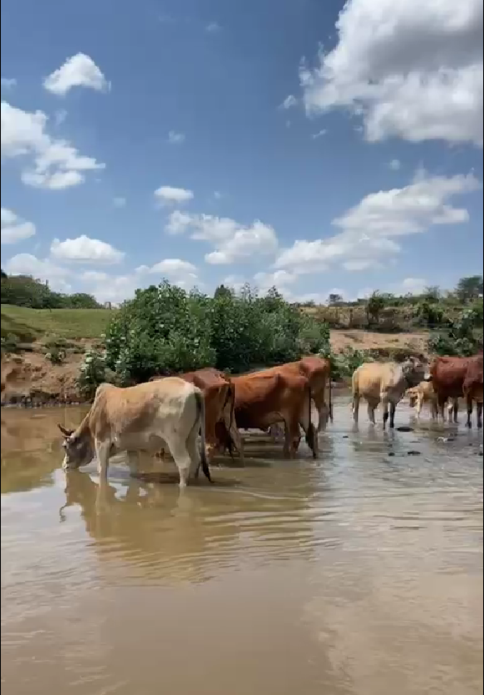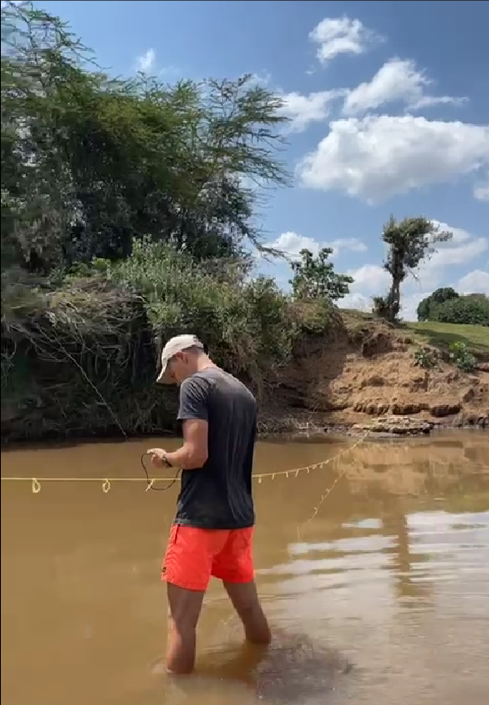

Figure 14: Example of unexpected work environments

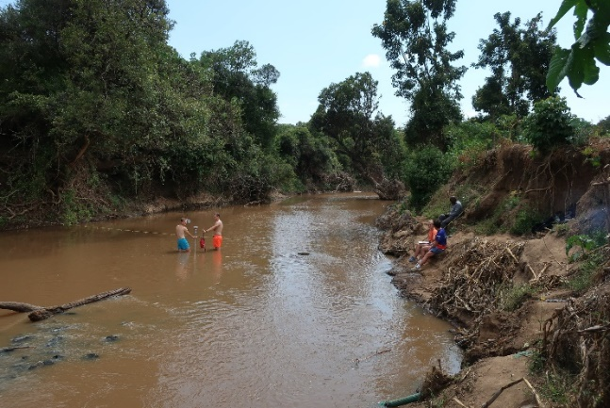

Figure 15: Challenging bankfull conditions

## 3.5.1 Determine a suitable cross section and its bankfull state

Upon arriving at the location it is important to walk along the stretch of the river. Finding a clear bankfull state which is also accessible to create a cross section is the ideal scenario. But as Figure 15 showcases, not all banks are as accessible. In such instances one has to accept that it is not possible to perform measurements at half a meter interval and do the best that is possible. Do keep in mind that the bushes on the left bank hinder satellite reception and one should consider increasing the measurement time of each point.

In other instances the bankfull state can unclear as marks are not always present. In this case local people can help out a lot as they are often able to point out how high the water rises. But always keep in mind that banks that show marks of human interference should be avoided. These are not natural banks and can thus lead to unexpected results.

## 3.5.2 Cross section measurement

Having selected a cross section of interest, the rope can be spanned across the river. Marking the interval in which the cross section should be executed. It is important to note this step takes quite some time and is not very eventful. For us the best practise was one person handling the Rover and keeping it upright and the other holding the receiver in the Drybag. A small speaker both sounded the timer each minute.

Figure 16

Figure 17

Figure 17: Failed water height measurement

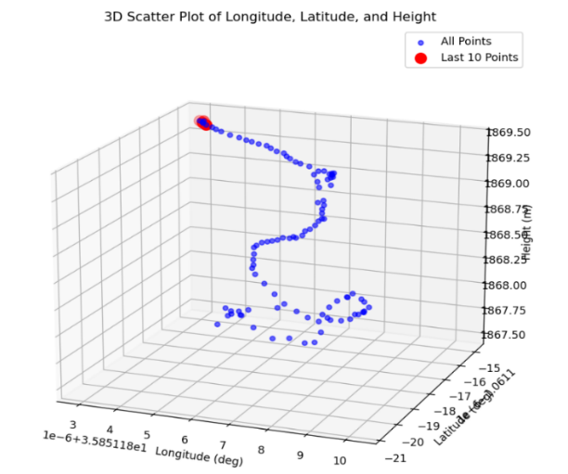

Figure 16: Cross section measurement

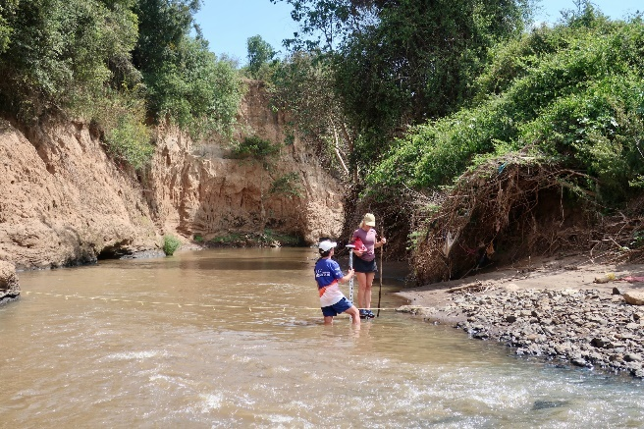

Sometimes installing the pegs into the ground can be quite challenging. Look for materials in your surroundings. Often a stone is close which can be used to drive the peg into the ground.

## 3.5.3 Water elevation measurement

This measurement can be executed straight after the cross sectional measurement. As the river is already crossed one can directly do the measurement on the first bank. Do remember to remove and re-install the SD card to create a new logfile. It is advised to perform the water height measurement for about 10 minutes for each location. This advice is based on the fact that the water height should (after post processing) return single value, not as points to fit a line through as one does when executing the cross sectional measurement. When shortening the time of this measurement events like seen in Figure 17 can occur. The rover had not stabilized yet and thus the official water height cannot be determined.

## 3.5.4 Length profile

The length profile measurement is repeating the same water height measurement but then both up- and downstream of the cross section. The one important thing to note is in the walking with the Rover: keep it upright and stable. If it is shaken too much or loses its vertical orientation, it might lose track of its position and has to recalibrate. This takes longer than the 10 minutes in which one will execute the water height measurement and as one is not able to look at the live measurement/fix, the failed measurement goes unnoticed until the post processing. Thus when it is too late.

## 3.5.5 Velocity profile

The velocity profile uses the same cross section as the one measured using the GPS. Using the same half meter intervals and set depth, one builds a table containing all velocity measurements.

A special case is when one is in need of extra validation data. Then, using the GPS, a new profile is build using 5 points. This to have a rough idea on the shape of the cross section of the river as this is needed to calculate the total wetted area. But do realise this validation step should be executed on several steps along the river.

## 3.5.6 Slope of the river

Under normal conditions this measurement is not needed. Unfortunately for us it turned out that our base station was unstable in its height measurements. The same location between different days resulted in height differences of up to 11 meters. This lead to the fact that in some parts of the river water had to flow upwards according to our measurements. Therefore we decided to perform one last elevation measurement along the entire river section, leaving the base at our home station. By doing this, all measurements during the day were prone to the same error and thus placed them relatively on the right elevation from each other. An important part was also performing a “sanity check”. A single point was measured twice during the day. Making sure the measured hight was now the same. In our case the measurements were still 40 centimetres apart. But considered as acceptable.

# Conclusion

Field measurements are a dynamic but important part of the research into flash floods. Capturing real world phenomena into models is always tricky and one should embrace the uncertainties encountered. Our step by step approach offers hand held to get reliable results under uncertain circumstances. But as every situation is unique, always take the local circumstances into account. Be creative in the innovative solution that is under development.

4. Process data

During the field measurements the SD-card was used to log the positional data relative to the satellites. The conversion from this relative position to files, that serve as input for the HEC-RAS model, takes several steps which are discussed below. To start with this step, the following needs to be installed and completed:

* Fieldwork measurements, discussed in Chapter 3.
* RTK post processing software, installation discussed in Appendix E.
* Python processing is further explained in Appendix F. 4.1 RTK software processing of the manual

# 4.1 RTK Software processing

In the case of the Enkare Narok river, eleven cross sections were measured. These cross sections were accompanied by additional measurements, like water height and local slopes measurements. This means that a lot of datafiles can be on the SD-card at a time. The point of this is to emphasize that it is crucial to keep a good administration of the files on the SD-card. A proper administration will prevent the loss of measurements.

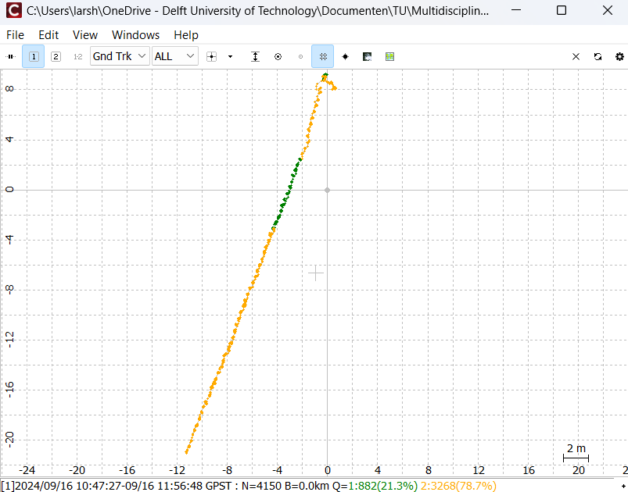Another point to mention is the accuracy of the measurements. Figure 18 shows the accuracy of a cross profile measurement. As explained in Appendix E of the main manual, yellow indicates submeter accuracy and green indicates centimetre accuracy. With this information, one could observe the following plot and think that the measurement is not that good. However, this is not always the case. Even if it is not centimetre accurate, if the location is based on at least 11 satellites, the accuracy can be assumed to be between 2 and 8 [cm]. This, in combination with at least 60 datapoints being registered per position, the measurement is still viable.

Figure 18 Output of RTKpost.exe

# 4.2 python processing

The Python processing, using the Data Processor Package, results in different outputs, namely:

* A .csv file with the cross profile points for each point;
* .png file of the cross profile for each point;
* .png file of the velocity profile for each point;
* One .csv file with the hydraulic parameters of all cross sections.

Below, these results for one of the cross sections of the Enkare Narok river are given. This shows how the output looks like.

Figure 19

Figure 20

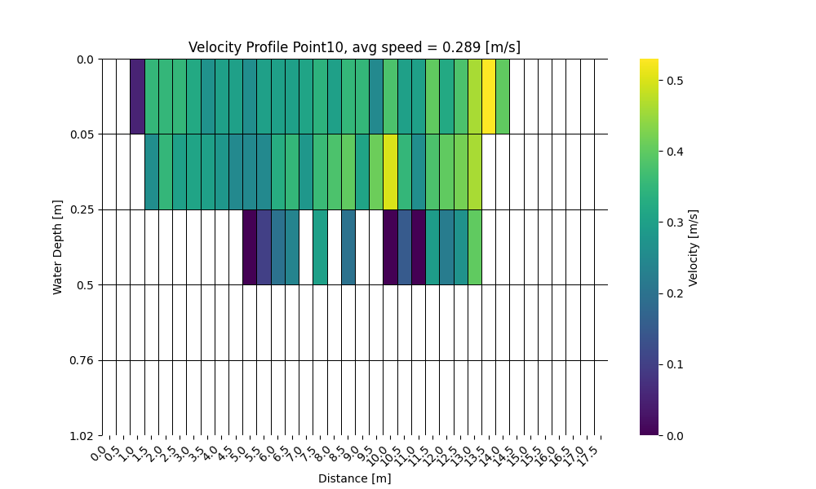

Figure 20: Example of velocity profile output

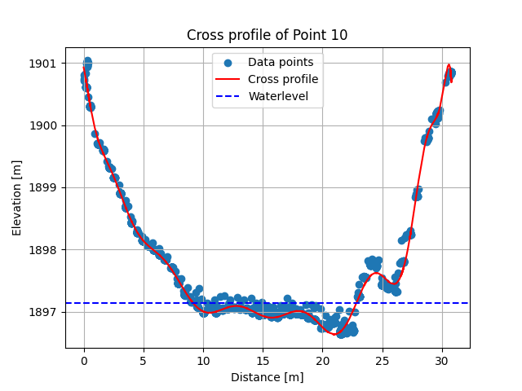

Figure 19: Example of cross profile output

The following figure presents an example of the Excel file with the computed hydraulic parameters. This output shows the hydraulic parameters of three cross sections. As can be seen, there are no parameters computed for point 7. This is the case as no valid water height was measured at that point. This emphasizes the fact that the user should take care of executing the measurements.

Figure 21: Example output of hydraulic parameters

In the case of the Enkare Narok river, some measurements didn’t go fully as planned. There were some measurements where the SD-card was already in the rover, so that the calibration process was also logged. This required some trimming of the dataset. Figure 22 visualises what part (blue part) was cut of the dataset to obtain a valid cross section. This shows how the *“INDIVIDUAL_CROSS_SECTION.ipynb”* can be useful in the data processing process.

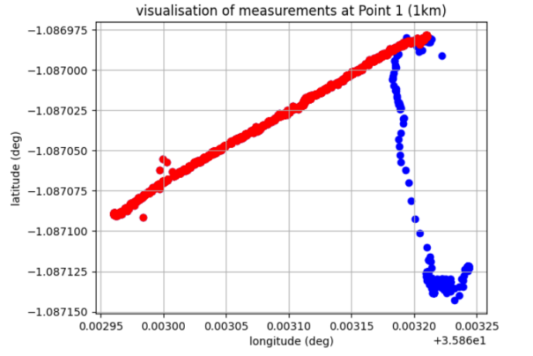

Figure 22: Application of the data trimming tool

The *“SLOPE_DETERMINATION.ipynb”* notebook turns out to be quite useful in determining the local slopes. It requires some input, namely three water height measurements per cross section, as shown in figure 23. The output however, is really concise and consist only out of one table with the local slope for each cross section, see figure 24. These slopes were used for the evaluation of the Manning equation and the boundary condition for the HEC-RAS model.

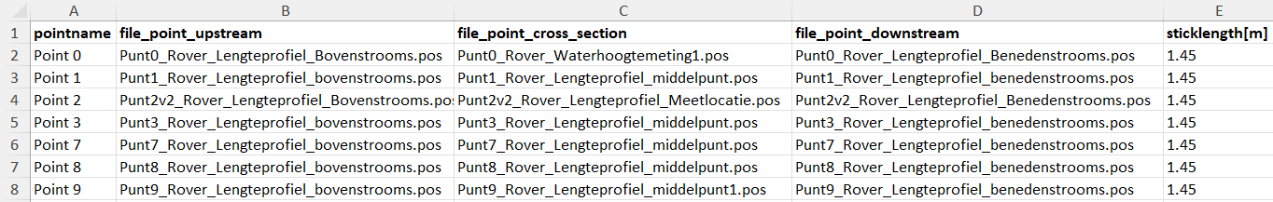Figure 23: Input of the SLOPE_DETERMINATION.ipynb

Figure 23

Figure 24

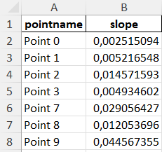

Figure 24: Output of the SLOPE_DETERMINATION.ipynb

# 4.3 Conclusion

In the case of the Enkare Narok river, a lot of measurements were done. It was a trial an error process, which eventually resulted in a streamlined measurement plan (explained in Chapter 3 and Appendix D of the manual) and data processing protocol. The data processing protocol is captured in the Data Processor package. This packages automates the process, once all the data is collected.

A few lessons were taken from the data processing that could be helpful for users in the future. Firstly, it is advisable to thoroughly understand the GPS system that you’re using and its capabilities. This can be done by thoroughly testing the GPS system before using it in the field. Testing procedures are described in Chapter 3.4 and Appendix C of the manual. Secondly, one should check the first few measurements that are done for any peculiarities. In the case of Narok, it turned out that the elevation that the GPS system measured, were inconsistent over the days. This resulted in a change in the applied measurement plan. The inconsistent height is of course just an example of what can go wrong, so the user should be critical on his measurements. The checking of the measurements can be done with the *“INDIVIDUAL_CROSS_SECTION.ipynb”* notebook, included in the Data Processor package. Lastly, it is emphasized to keep a good administration and folder structure for the measurement data. With the advised measurement plan, a lot of files will be generated and without a good system, it is easy to lose track. A lack of clear structure can in the worst case result in having to redo (some of) the measurements.

In conclusion, the RTK processing software and the Data Processor package are fully equipped to process the measurement data. However, the user should be aware of the pitfalls and work in an orderly manner.

5. Build model

This chapter focuses on building a one-dimensional hydraulic model of the Enkare-Narok river in Narok County. The objective is to find the critical discharge upstream of the river, that leads to flooding at the flood point, which is defined as the point where the drainage channels enter the Enkare-Narok river, and to find the corresponding warning time.

First, an alternative method based on manual computations is discussed. In Paragraph 2, modelling of a flash flood, in the general sense, is discussed. Subsequently, the models that were created for this case study, are described. In Paragraph 4, conclusions based on the line model are given, which are followed by a sensitivity analysis of this model, in Paragraph 5. The chapter is concluded in Paragraph 6, stating the main findings of the models made for the case of Narok Town.

# 5.1 Alternative manual computations

For data-scarce areas often simpler methods than models are recommended, in order to give an estimation of parameters that are to be determined. An example of a such a method, and the application of it in Narok Town, is discussed here.

Discharges can be calculated based on Manning’s formula, which can be combined with a method by Leopold & Maddock. By combining these two methods, one should be able to calculate the discharge in a channel based on either a measured width, depth, or flow velocity. This can be used to convert a water level gauge upstream to a discharge. Similarly, based on a (high) discharge, a flow velocity can be determined. This methodology is described in the manual, in Appendix I. The results for these calculations in the river reach in the Enkare Narok river are given in Appendix B in this document. A Manning coefficient is determined based on the base flow, as was measured, and results in an average value of $n=0.0708$ [s/m(1/3)]. It is noted that this value is higher than would be expected based on literature. This coefficient is used to calculate discharges per cross-section, for a bank full state of the river, simulating a flash flood. Similarly, the corresponding flow velocities are determined. These bank full state outcomes are used as input for the Leopold & Maddock method. Unfortunately, this resulted in non-conclusive relationships between geometry characteristics width, depth, and velocity and the discharge, per cross-sections. The relationship between depth and discharge gave the best result and did deliver calculated discharges in the same order of magnitude as the calculations based on Manning’s equation. It is recommended to also discover the relations based on a base flow state of the river, which was also done for this river reach. However, these results were also non-conclusive and therefore not added to this report.

# 5.2 Modelling a flash flood

The recommended approach for building a model that can simulate a flash flood consists of three steps:

1. Creating the complete geometry of the part of the river that has to be modelled.
2. Creating a steady flow model to calibrate Manning’s coefficient.
3. Defining an unsteady model to simulate the flash flood.

## 5.2.1 Geometry

Only a small part of the Enkare-Narok river will be modelled. The bottleneck of the river is the bridge in the centre of the town, therefore, this will be the downstream boundary of the model. The upstream boundary is the point where the sensor will be placed. For this model, a point 16.5 km upstream of the bridge is chosen, illustrated in Figure 18. This means that 16.5 km of the river will be modelled. The determination of these boundaries is further elaborated in Chapter 2 of this document. The river will be modelled as one reach without any junctions. There will be accounted for tributaries, by adding or subtracting a discharge at the locations where they enter or exit. More information about the geometry and terminology used by HEC-RAS is given in Appendix G of the manual.

Figure 25: Upstream boundary

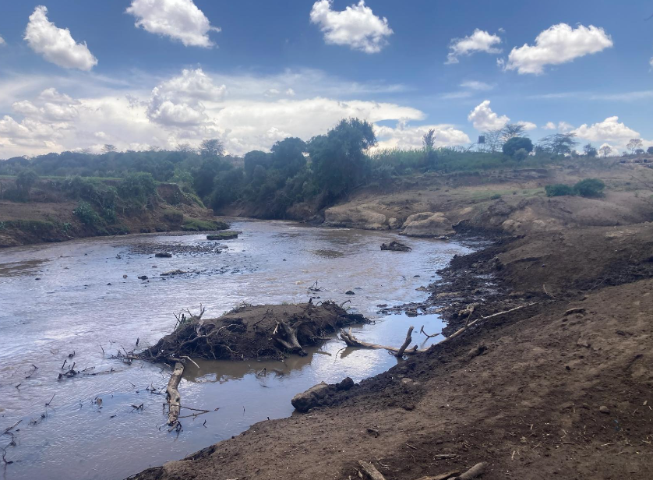

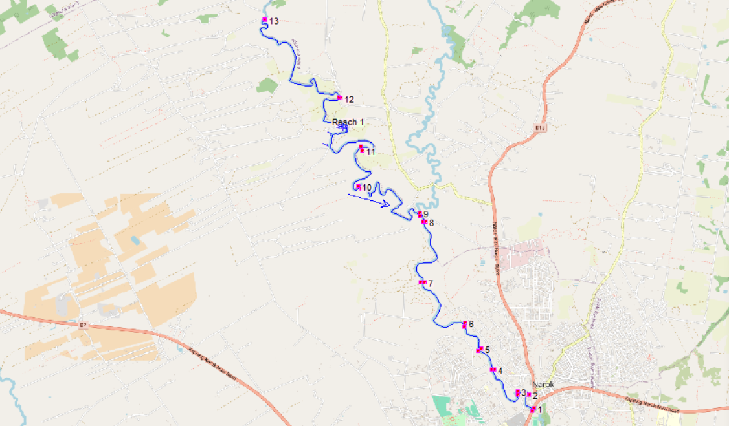The geometry of the model, width and elevation of the river, is based on field measurements. As explained in Chapter 4.1, ten cross-sections have been measured. Additionally, the data of three cross-sections was already available, retrieved by Dorius LePoole (Poole, 2024). The geometry of the model is illustrated in Figure 26.

Figure 26: Geometry of the model

## 5.2.2 Steady Flow

After completing the geometry, the steady flow data can be specified. The following input is required to run the steady flow model:

### Flow regime

The flow regime during the validation measurements is used as input for the steady flow model to be able to calibrate Manning’s coefficient, as explained. The flow regime was assumed to be subcritical due to the low velocities observed when standing in the river. This had been verified by applying the average velocity and depth of the cross-sections, obtained in Chapter 4, to the Froude number formula. For each cross-section, Froude’s number was less than 1, meaning that the flow is subcritical.

### Boundary conditions

Since the flow regime is subcritical, only a downstream boundary condition is necessary. The downstream boundary is located at the bridge. The boundary condition is defined as a normal depth, for which an energy slope has to be entered. Since no information is available on the energy slope, the bed slope is used as an approximation (US Army Corps of Engineers Hydrologic Engineering Center, 2016), which is equal to 0.00251 [m/m]

### Peak flow data

The river is modelled as one reach. Therefore, HEC-RAS only requires one discharge as input. The discharge calculated with the validation data is used, and is equal to 1.85 $\left[{m^{3}}/s\right]$. At cross-section 9, a tributary enters the main river. The discharge downstream from the junction is 1.74 $\left[{m^{3}}/s\right]$. At cross-section 3, the drainage channels enter the main river. The discharge of the drainage channels is approximately 0 $\left[{m^{3}}/s\right]$, as they only carry water in case of heavy rainfall in the Esamburmbur and Kakia sub-catchments. During the validation measurements, this was not the case.

As explained in the manual, determining a suitable Manning’s coefficient for the model is an iterative process. As a starting value, a value found in literature was used. Manning’s coefficient can range between 0.01 and 0.07 [$s/m^{\frac{1}{3}}$]. For a river like the Enkare-Narok river, Manning’s coefficient will probably range between 0.03 and 0.05 [$s/m^{\frac{1}{3}}$]. A more detailed explanation is given in Appendix I of the manual. An average value of 0.04 [$s/m^{\frac{1}{3}}$] is used as the starting value. The iterative process resulted in a Manning’s coefficient of 0.1 [$s/m^{\frac{1}{3}}$], which does not fall within the range of possible Manning’s coefficients. Manning’s coefficient depends highly on the measured water level and velocity. Since these measurements were not very accurate, the determined Manning’s coefficient is not reliable.

## 5.2.3 Unsteady flow

Calculations with the unsteady flow model are executed twice. Once to validate the model and once to simulate the flash flood. Both the upstream and downstream boundary conditions need to be specified when simulating unsteady flow. The upstream boundary condition is defined as a flow hydrograph, while the downstream boundary condition is defined as the normal depth, which is equal to the normal depth used in the steady flow model.

### Validation

For validation of the unsteady flow model, the same validation data was used as for the steady flow model. The flow hydrograph will be defined using a constant discharge, the discharge based on the validation measurements at the most upstream cross-section, equal to 1.85 $\left[{m^{3}}/s\right]$. A simulation time of one hour is employed. At cross-section 9, a flow hydrograph is defined to account for the tributary. This hydrograph is held constant at 1.74 $\left[{m^{3}}/s\right]$. The discharge of the drainage channels is equal to 0 $\left[{m^{3}}/s\right]$, similarly as the steady state model.

### Flash flood

The discharge during a flash flood is a lot higher than during the validation measurements. The discharge is specified in the stage/flow hydrograph defined at the upstream boundary condition. In this case, the discharge does not remain constant. The stage/flow hydrograph starts at the discharge prior to the rapid rise in water level, and will continue to increase until the critical discharge is reached, which leads to a flood at the flood point. In an ideal situation, you would have measurements to define the stage/flow hydrograph. This is very challenging, as measurements in these conditions, a high water level and velocity, go hand in hand with dangerous situations. Therefore, the stage/flow hydrograph is based on the bank-full discharge, determined by the Manning method, at cross-section 13, as illustrated in Figure 26. This discharge is accompanied by a lot of uncertainties, since the bank-full level of the river is based on judgement by sight. The highly varying flow area of the cross-sections is an indication of this uncertainty. The simulation time, the step size of the discharge during the simulation and the initial value of the discharge remains very uncertain as well.

Unfortunately, the unsteady flow model with the validation data as input, did not result in realistic output, as explained in the manual. To be able to find the root cause, a simplified model was taken as starting point and expanded step by step. The outcome of this analysis is provided in the following paragraph.

# 5.3 Models

It was suspected that the problem originated from the terrain data and the projection file uploaded in RAS Mapper. It appears that HEC-RAS either geo-references the cross-sections even when no coordinates are provided, or it still considers the elevation data from the Digital Elevation Model (DEM), despite this data being removed from the cross-sections. The disadvantage of RAS Mapper is that you must specify a projection file and add a terrain layer before you can include web imagery, even if you don’t want to geo-reference your project or use a DEM. It seems that HEC-RAS is primarily designed for creating elevation data using a DEM rather than using field measurements.

This is just a hypothesis. The problem could also originate from another aspect of the model. To rule this out, intermediate models were created, as explained. Per intermediate model, the following conclusions were drawn:

### Simplified line model

There are no issues with creating the geometry in HEC-RAS with rectangular cross-sections.

### Expanded line model

There are no issues with the distance between two subsequent cross-sections and more complex cross-sections.

### Complete line model

The malfunctioning of the full model is most likely related to either the representation of the actual course of the river, including incorporation of bends, or the underlaying terrain. Furthermore, the model aligns approximately with the validation data.

### Import full model geometry

The terrain data and projection file were indeed the root cause of the problem. Additionally, it can be concluded that representing the actual course of the river is not the problem and drawing the course of the river does not incorporate the effect of bends. Furthermore, the model aligns approximately with the validation data.

It can be concluded that the complete line model provides realistic output. The disadvantage is that bends are not incorporated, therefore, the model is simplified more than was desired.

# 5.4 Conslusion based on complete line model

As explained, the difficulty of modelling with HEC-RAS lies in incorporating the bends of the river, which is yet to be understood. However, the critical discharge and corresponding warning time can still be concluded from a model without bends, namely the *Complete line model*. They will be a bit more conservative, since bends cause energy losses due to friction and turbulence. This will result in a lower average velocity of the water and thus, a longer travel time to the flood point.

Computing an exact warning time is not possible with this manual, as there is no sufficient data for the boundary conditions in the unsteady state. Estimating a flow hydrograph based on the estimated bank-full discharges seemed to be too uncertain, as explained in 5.2.3.

Setting the correct boundary conditions when modelling unsteady flow is crucial for getting a representative output. The following boundary conditions should be known to estimate the warning time:

1. Stage/flow hydrograph at the upstream boundary
2. Flow hydrograph for the lateral inflows where tributaries enter
3. The bed slope, used for calculating the normal depth, at the downstream boundary

After determining the critical discharge and the corresponding warning time, the sensitivity of the model can be determined. This is done by removing cross-sections one by one until the model’s output differs too much from the original model.

## 5.4.1 The case of narok town

In the case of Narok Town, both the upstream stage/flow hydrograph and the lateral inflow hydrographs are unknown. Therefore, it is difficult to determine whether the outcome is representative for the actual flow of the river. However, this section will consider different flow hydrographs, to show how the results can be interpreted and what the effect of changing the hydrographs is on the model’s outcome.

### Adding an upstream stage/flow hydrograph

The first step is to only add a stage/flow hydrograph at the upstream boundary, which increases from 1.85 $\left[{m^{3}}/s\right]$ to 200 $\left[{m^{3}}/s\right]$ within two hours, the water elevation at this cross-section increases from 1900.85 metres to 1904.23 metres, which is equivalent to the bank-full height. After two hours, the simulation was ran for two more hours at a discharge of 200 $\left[{m^{3}}/s\right]$. The result of the simulation after two hours is shown in Figure 27. The velocity in the channels varies between 2.5 [m/s] and 3.1 [m/s], which corresponds to the values found for the wave celerity. The bank full capacity at the bottleneck, the most downstream location, is reached after 2 hours and 58 minutes.



Figure 27: Simulation for upstream boundary. The striped line is the Energy Gradient; The blue is the water level

### Incorporating tributaries

To add a tributary, a new river station has to be added and a lateral inflow hydrograph is added to this river station. The starting time of the hydrograph is not set to zero, as was done for the upstream boundary. If this would be the case, all flows would act separately, as is shown in Figure 28.

2

9

13

Figure 28: Tributaries acting individually

In this case, the upstream flow conditions would not be relevant anymore, as the lateral inflow will reach the bottleneck first. To solve this, the starting time of the lateral inflow hydrograph is adjusted to the time when the upstream flow reaches the tributary. Flowing from station 13 to station 9, takes 1 hour and 54 minutes. At point 9, a lateral inflow hydrograph is created in which the discharge rises in an hour from 1.74 $\left[{m^{3}}/s\right]$ to 70 $\left[{m^{3}}/s\right]$, this is according to the ratio as explained in Chapter 3.2. The cumulative flows from point 13 and 6 together take 2 hours and 40 minutes to reach point 2, the hydrograph at that point goes from 0 $\left[{m^{3}}/s\right]$ to 200 $\left[{m^{3}}/s\right]$ within an hour.

### Result

After the tributaries have been added, the unsteady flow model can be run. Running the model with the values mentioned above will result in 2 hours and 50 minutes before the capacity of the bottleneck is reached. Figure 29 shows the result. The corresponding discharge is 146.20 $\left[{m^{3}}/s\right]$. However, this result cannot be interpreted as being a realistic warning time for a flash flood. In order to do so, the boundary conditions for the unsteady flow should be known.

Figure 29 Outcome complete line model

Adding the lateral inflows only resulted in a time difference of 10 minutes, when compared to only adding an upstream boundary condition.

The model has also been ran for an upstream discharge of 300 $\left[{m^{3}}/s\right]$, this did not result in a much shorter warning time. The time difference was 2 minutes shorter compared to the case of 200 $\left[{m^{3}}/s\right]$.

# 5.5 Sensitivity analysis

To determine how many cross-sections are needed to model the river, a sensitivity analyses was conducted. This analysis was conducted on the unsteady flow model as shown in figure 4. Although the outcome might not be a precise representation of the river, it was shown with the verification data that the results are consistent. Therefore the output of the model can still be used as a reference for the sensitivity analyses. The outcomes per analyses are compared to the result obtained out of the unsteady flow model, ran with only the upstream boundary condition as previously shown. The outcomes for each analyses will be compared to the earlier computed time, being 2 hours and 58 minutes. The input discharge is set the same as for the case only simulating with an upstream boundary condition.

1. Deleting all cross-sections between 13 and 1

Running the model with only two cross-sections leads to a significant reduced time in which the capacity at bottleneck is reached, 2 hours and 20 minutes. This is an error of 21% compared to the original situation.

1. Deleting cross-sections 5-10

Running the model with only 7 cross-sections leads to a less significant reduced time in which the capacity at bottleneck is reached, 2 hours and 49 minutes. Removing 6 cross-sections leads to an error of 10 minutes, which is a mistake of around 6%.

1. Deleting 8 cross sections

In this case the water takes 2 hours and 53 minutes to reach the bankfull capacity at the bottleneck. Only the cross-sections 1,5, 9, 11 and 13 remain. Therefore it can also be concluded that it matters which cross-sections are removed or not. Although more cross-sections have been removed, the error is less than for the second case. This is most probably because in this case the cross-sections have been removed more evenly.

1. Case 3 and removing cross-section 5

This leads to a time of 2 hours and 40 minutes before the water reaches the bottleneck, this is an error of 11%.

It seems that removing 8 out of the 13 cross-sections is the maximum limit at which the error is acceptable. When removing an additional cross-section the error goes up to 10% compared to the original case. Thereby the result is also depended on which cross-sections are removed, removing them evenly leads to better results.

# Conclusion

The critical discharge based on the complete line model is equal to **146 [m3/s]**, and the corresponding warning time is equal to **two hours and fifty minutes**. Although a conclusion was drawn, it did not have the desired accuracy for several reasons:

* The calibrated Manning’s coefficient did not fall within the range of possible values. This is probably caused by inaccurate measurements of the water level and flow velocity. Manning’s coefficient is changed until it corresponds to the water levels and velocities that are provided, therefore, it depends highly on these measurements.
* The upstream boundary condition in case of a flash flood is defined as a stage/flow hydrograph. To be able to define this properly, continuous measurements are required, or measurements have to be conducted during these conditions, which is very dangerous. Therefore, the stage/flow hydrograph is based on the bank-full discharge calculated with the Manning method. This discharge is inaccurate as it is based on judgement by sight of the bank-full level of the river. The simulation time, the step size of the discharge during the simulation time, and the initial discharge remain very uncertain as well.
* Bends are not incorporated into the model. When bends would be incorporated, it would result in a higher warning time. Bends lead to a deceleration of the water and an increase in water level.

6. Implementation

This manual is the result of a ten week project in Narok Kenya, of which it is important to note that a flood sensor has not been installed during the project. Nonetheless, information on the implementation was gathered. This chapter discusses the knowledge obtained and the means used to obtain the knowledge.

# 6.1 Partners involved

No agreements have been made in terms of the partners involved in the actual functioning of a Flood Early Warning System in Narok Town. The local authorities, and the local community, are described in Chapter 1. With these parties, discussions will need to be held to decide on role distributions and responsibilities.

The Kenya Meteorological Department is traditionally responsible for weather forecast and alerts and warnings in Narok County. Therefore, they would be the best partner for TEMBO to maintain and upkeep an early warning system. Collaborations between TAHMO and the KMD have been maintained for a while already, and this will be an useful foundation for further collaboration. The local office of the KMD in Narok Town is also aware of possible responsible parties in the local community, and has a good reputation, of being trustworthy and knowledgeable.

Funding possibilities for the implementation of a FEWS in Narok Town, have not been explored.

# 6.2 Functioning of the system

Processing of the warning, and defining a communication method, have both not been concluded upon for the case study in Narok Town. First explorations on the topic are described here.

## 6.2.1 Processing the warning

Processing of the warning, given by the water level gauge, into an actual warning, is not explored extensively. Some brief talks with the KMD have concluded in a possible set-up as follows: The sensor should give an automated warning from the upstream location to the local KMD office. The office will check this warning, based on the delivered values, and on communication with someone close to the gauge location. The office will then be responsible for further communication of the warning to all intended recipients.

## 6.2.2 Communication of the warning

Similar to the steps given in Paragraph 6.2.2 of the manual, a brainstorm session has been held with students of the Maasai Mara University, faculty of Natural Resources. Their answers are included in Appendix C. However, not much of it was written down. The main takeaways of this session are described here:

* Sirens are considered the best way of communication. The message is clear, even for people who don’t understand the actual meaning of the warning. Furthermore, will a siren reach everybody present in the area, and will it overcome struggles such as language barriers, illiteracy, and availability of phones and other media channels.
* Another similar communication method is the use of speakers on a car, driving to the expected floodplain.
* In terms of communication via cellular devices, it was noticed that not everyone has access to internet, therefore SMS alerts are recommended.
* Local media were mentioned multiple times as well. Especially for warnings with a longer warning time, for example a couple days, this would be a good communication medium. Local media would be able to reach many recipients, and also give the corresponding information that belongs to the warning.

The issue of deciding on a suitable communication method is also discussed in a round of interviews in the floodplain of Narok Town. It was stated that suitable communication methods include clear sounds, like a siren, and methods via telecom, like SMS. It was also stated that neighbouring shop owners will warn each other, meaning that not everyone necessarily needs to be reached.

# 6.3 Selecting a sensor

In the case of Narok Town, there was no conclusion drawn on which sensor is to be selected and no significant possibilities were explored.

# 6.4 Installation of the sensor

The installation of the actual sensor, which acts as the trigger of the warning system, is complex. In many African countries, equipment in the field such as sensors, often get stolen. It has proven to be difficult to find adequate measures. (TEMBO Africa, 2024) The location for the sensor, its installation, and the maintenance remain as always a challenge.

## 6.4.1 Location

So far, using existing infrastructure has been found to be the best solution. An example is in suspending the sensor from a bridge. This leaves the sensor relatively unreachable for theft, and directly above the river of interest. The main downside of the approach is the maintainability of the system.

Talks with Nick van de Giesen pointed towards the use of beehives to install and hide the sensors in. Beehives are common and often undisturbed structures along canals, providing the perfect opportunity to install and hide required sensors. An example was found at the Maasai Mara university, but has not yet found a real world application.

Following from the interactive session with students of the Maasai Mara University, a lot of attention was pointed towards the security of the sensor itself. It should be constructed from rigid materials such as steel and concrete. Ideas like cages and tall concrete poles were suggested, as seen in Appendix C. Another solution was found in the installation of “temper sensors”, which track the location of the sensor. As soon as it moves, one is notified. The placement of guards was also seen as a possibility.

The location will also highly depend on the possibility to include local community members or other parties. As is described in Paragraph 6.1 of the manual, involvement of local community members will ad to the safety and security of the sensor.

In Narok Town, an example of a guarded location was found at the water inlet for the water supply for Narok town. During the execution of the measurements they directly noticed us and inquired about our intentions. Unfortunately, this water inlet was located only 6 kilometres from the bottleneck in Town and would thus result in a warning time that would be too short.

Schools or other social institutions are also considered as relatively safe locations. These are often located in the midst of the local community and thus enjoy a lot of social control.

Especially in the case of Narok Town, the river is used along its full length by farmers and families. It thus enjoys a lot of (foot) traffic. Which in any way can (accidentally) tamper with the functioning of the sensor. It is therefore important to have it as robust as possible.

## 6.4.2 Installation

It is believed that the installation is location specific and following from the previous paragraph, even then there is a lot of disagreement on the best approach. A possible solution would be to check the way other sensors in the local context are installed.

## 6.4.3 Maintenance

All people involved stressed the importance of a maintenance plan. More than often after the installation of a sensor the involved people move on, to other projects. Slowly over time the sensor loses its connection to the involved parties and eventually is forgotten. Or there is no one left who has the knowledge on how to act if the sensor fails. A good example is the previously installed flood early warning sensor that was installed in Narok Town, but got stolen. None of the involved institutions acted on this and therefore Narok Town has lost this predictive sensor.

Bibliography

Ardusimple. (2024, 10 30). *GPS/GNSS Antenna Installation Guide*. Retrieved from ardusimple.com: https://www.ardusimple.com/gps-gnss-antenna-installation-guide/

Citizen TV Kenya. (2020, January 26). *Flash floods sweep through Narok town for one hour*. Retrieved from YouTube: https://www.youtube.com/watch?v=KJET2vu9X4c

David Rogers, V. T. (2011). *Costs and benefits of early warning systems.* Global Assessment Report on Disaster Risk Reduction.

Etienne Umukiza, J. M. (2021). *Impacts of Land Use and Land Cover Changes on Peak Discharge and Flow Volume in Kakia and Esamburmbur Sub-Catchments of Narok Town, Kenya.* hydrology.

Etienne Umukiza, J. M. (2022). *Improving Drainage Systems in Urbanised Areas under Projections of Land-Use Changes: Case Study of Kakia and Esamburmbur Channels of Narok Town, Kenya.* London: London Journals Press.

Eva Audrey Yessito Houessou-Dossou, J. M. (2019). *Flood Frequency Analysis Using Participatory GIS and Rainfall Data for Two Stations in Narok Town, Kenya.* hydrology.

HydroSHEDS. (2024, September). *HydroSHEDS Core Data Downloads.* Retrieved from HydroSHEDS: https://www.hydrosheds.org/hydrosheds-core-downloads

Kahuthu, J. (2024, September). Kenya Meteorological Department - Narok office.

Kenya Meteorological Department. (2024, October). *Latest/Alerts*. Retrieved from Ministry of Environment and Forestry, Republic of Kenya: https://meteo.go.ke/

Kirui, K. (2024, May 3). Fear and panic grips Narok town residents as Olopito dams water levels rise. *The STAR*, pp. https://www.the-star.co.ke/news/2024-05-03-fear-and-panic-grips-narok-town-residents-as-olopito-dams-water-levels-rise.

Luna B. Leopold, T. M. (1953). *The hdyraulic geometry of stream channels and some physiographic implications.* Washington, D.C.: United States Government Printing Office.

Maasai Mara University. (2024, October). *various webpages*. Retrieved from Maasai Mara University; eng'eno e puaan: https://www.mmarau.ac.ke/

Mabwoga, D. S. (2024, September 9). Introduction meeting student group and Maasai Mara University.

Mossel, S. (2020). *Flood Early Warning Systems in Urban Flood Prone Areas Narok County, Kenya: A Feasability Study.* Delft University of Technology.

Narok County Government. (2024, October). *Narok Water And Sewerage Services Company Limited (NARWASSCO)*. Retrieved from https://narok.go.ke/naruwasco/

NASA's Earth Observing Centre. (2024). *Shuttle Radar Topography Mission (SRTM)*. Retrieved from eospso.nasa.gov: https://eospso.nasa.gov/missions/shuttle-radar-topography-mission#:~:text=The%20Shuttle%20Radar%20Topography%20Mission,digital%20topographic%20database%20of%20Earth.

Nation. (2023, April 3). *Floods hit Narok town following heavy evening downpour*. Retrieved from YouTube: https://www.youtube.com/watch?v=6QxqxX74aDo

National Water Harvesting & Storage Authority. (2024, October). *Our Achievements.* Retrieved from waterauthority: https://waterauthority.go.ke/our-achievements/

NTV Team. (2023, December 7). *Video: Narok flash floods sweep away cattle*. Retrieved from NTV Kenya: https://ntvkenya.co.ke/news/video-narok-flash-floods-sweep-away-cattle/

OpenStreetMap. (2024, September). *Export data.* Retrieved from OpenStreetMap: https://www.openstreetmap.org/#map=13/-1.07797/35.85431

Poole, D. L. (2024). *Rapid hydraulic assessment tool for river floods using hydraulic geometry relations in data scarce areas.* Delft: Delft University of Technology.

Sayagie, G. (2015, April 29). Narok floods leave 15 dead with property worth millions destroyed. *NATION*.

TEMBO. (2024, October 4). *Transformative Environmental Monitoring to Boost Observations in Africa*. Retrieved from https://temboafrica.eu/

TEMBO Africa. (2024). *Design Modular Flood Early Warning System (FEWS) - V1.*

United Nations Office for Disaster Risk Reduction. (2024, October). *Flash Flood*. Retrieved from UNDRR.org: https://www.undrr.org/understanding-disaster-risk/terminology/hips/mh0006

US Army Corps of Engineers Hydrologic Engineering Center. (2016). *HEC-RAS River Analysis System.*

Venutelli, M. (2005). *A Constitutive Explanation of Manning's Formula.* Meccanica, Springer.

Water Resources Authority. (2024, October). *Accounting for every Drop*. Retrieved from Water Resources Authority: https://wra.go.ke/

Wikipedia. (2024, October). *Mau Forest*. Retrieved from Wikipedia: https://en.wikipedia.org/wiki/Mau_Forest

Williams, G. P. (1978, December). Bank-full discharge of rivers. *Water Resources Research*, pp. Volume 14, Issue 6, page 1141-1154.

World Bank. (2021). *Narok County Flood Early Warning Communication Strategy.* World Bank.

Appendix A. Student Input Warning Time

# Set case

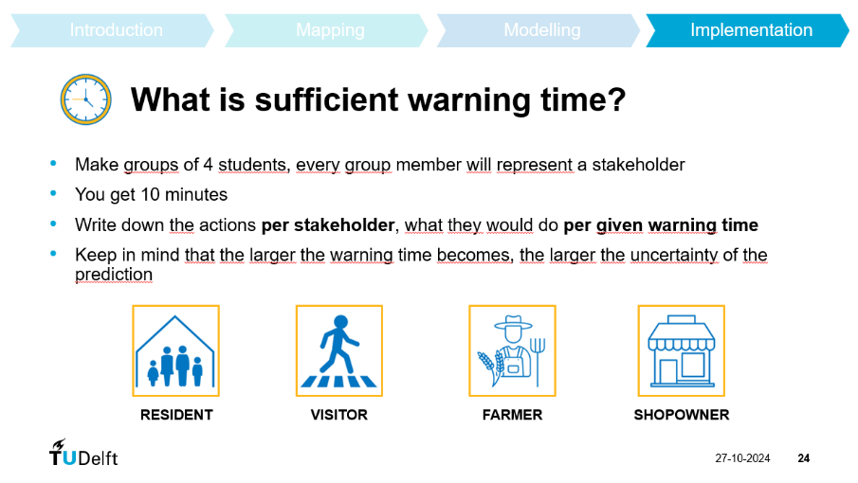A question was opposed to a group of students at Maasai Mara University, Narok, Kenya. The question was described in a PowerPoint, of which two slides are attached here to show the casus as depicted, see the Figures 30 and 31 below.

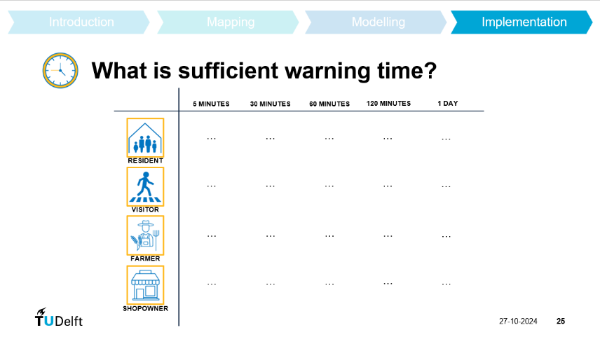Figure 30: Casus slide 1

Figure 31: Casus slide 2

# Student responses

All responses of students, or student groups, are collected in the tables. Due to time restrictions, not all boxes are filled out. The students have written down the answers themselves.

Table 2: Actions of different stakeholders in case of a flood warning, for different warning times: respondent 1

|  |  |  |  |  |
| --- | --- | --- | --- | --- |
|  | *Resident* | *Visitor* | *Farmer* | *Shop owner* |
| **5 minutes** | - | Difficult to get away due to non-familiarity with the surrounding | - | - |
| **30 minutes** | - | A bit easier in escaping, but at times difficult in a larger group | - | - |
| **60 minutes** | - | Easier to evacuate, but difficult for one who is not conversant with the directives i.e. warning alarms | - | - |
| **120 minutes** | - | Better timeframe for a not so rushed evacuation of people’s belongings | - | - |
| **1 day** | - | Perfect for evacuation | - | - |

Table 3: Actions of different stakeholders in case of a flood warning, for different warning times: respondent 2

|  |  |  |  |  |
| --- | --- | --- | --- | --- |
|  | *Resident* | *Visitor* | *Farmer* | *Shop owner* |
| **5 minutes** | Pick essential items ie ID, wallet, phone, meditation | * Contact local authority * Follow instruction from hotel * Leave for a safe location | Turn off irrigation system | Notify customers |
| **30 minutes** | Essential documents ie cert | * Check local emergency services to confirm impact of the situation * Avoid traveling back | More livestock to higher ground, secure machinery | More things to higher shelves |
| **60 minutes** | Emergency kit (clothes, god, water) | - | Relocate remaining livestock | - |
| **120 minutes** | Relocate to dedicated evacuation centre, inform others | - | Plan for post flood recovery | - |
| **1 day** | - | - |  | - |

Table 4: Actions of different stakeholders in case of a flood warning, for different warning times: respondent 3

|  |  |  |  |  |
| --- | --- | --- | --- | --- |
|  | *Resident* | *Visitor* | *Farmer* | *Shop owner* |
| **5 minutes** | Take items e.g. ID/Certificate and run away (immediate evacuation) | Run | Run | Run |
| **30 minutes** | Take essential items (ID, certificates) | Contact to inquire safe place | * Evacuate animals to higher grounds * Take farm inputs | Basic stock |
| **60 minutes** | * Inform immediate neighbours * Clothes | Contact to understand the impact (how intense) | - | - |
| **120 minutes** | Alert | - | - | - |
| **1 day** | - | - | - | - |

Table 5: Actions of different stakeholders in case of a flood warning, for different warning times: respondent 4

|  |  |  |  |  |
| --- | --- | --- | --- | --- |
|  | *Resident* | *Visitor* | *Farmer* | *Shop owner* |
| **5 minutes** | - | - | - | - |
| **30 minutes** | - | - | - | - |
| **60 minutes** |  | - | - | - |
| **120 minutes** | - | - | - | Only light stocks from the shop can be safe |
| **1 day** | - | - | - | Can be sufficient to transport stock to the safe place from the flooded area |

Table 6: Actions of different stakeholders in case of a flood warning, for different warning times: respondent 5

|  |  |  |  |  |
| --- | --- | --- | --- | --- |
|  | *Resident* | *Visitor* | *Farmer* | *Shop owner* |
| **5 minutes** | * Escape * Rescue others if possible | Escape, look for a safe place | Escape | Escape to a safe place to safe your life |
| **30 minutes** |  | - | - | - |
| **60 minutes** | Evacuate temporarily to safe places | - | Carry important things | Escape with other things |
| **120 minutes** | - | - | - | - |
| **1 day** | Build temporary cottages in highlands | - | Evacuate with your livestock to safer places | Evacuate woth your property to a safe place |

Table 7: Actions of different stakeholders in case of a flood warning, for different warning times: respondent 6

|  |  |  |  |  |
| --- | --- | --- | --- | --- |
|  | *Resident* | *Visitor* | *Farmer* | *Shop owner* |
| **5 minutes** | I leave everything and run away escaping to a better place | - | - | - |
| **30 minutes** | I will signal or alert my neighbours and we escape to where no flooding | - | - | - |
| **60 minutes** | I will be able to save a little of my properties | - | - | - |
| **120 minutes** | Escaping and sign al to everyone | - | - | - |
| **1 day** | I will plan a better plane to go leave with my everything and everyone near me, we go | - | - | - |

Table 8: Actions of different stakeholders in case of a flood warning, for different warning times: respondent 7

|  |  |  |  |  |
| --- | --- | --- | --- | --- |
|  | *Resident* | *Visitor* | *Farmer* | *Shop owner* |
| **5 minutes** | Just run away to a place which is a high region | Are enough to run away | Is not enough to harvest if ready | One can only run away |
| **30 minutes** | - | - | - | - |
| **60 minutes** | Call all the people you know if they are not aware | - | - | - |
| **120 minutes** | - | - | - | Is the best, because one day is enough but some may think it’s a false warning |
| **1 day** | - | Is enough to return home | Is enough to evacuate animals and important things | Can be enough to collect things from the shop |

Table 9: Actions of different stakeholders in case of a flood warning, for different warning times: respondent 8

|  |  |  |  |  |
| --- | --- | --- | --- | --- |
|  | *Resident* | *Visitor* | *Farmer* | *Shop owner* |
| **5 minutes** | Run away to safety | - | - | - |
| **30 minutes** | Will be more secure because they can evacuate some of their items | - | - | - |
| **60 minutes** |  | - | - | - |
| **120 minutes** | - | - | - | Is the best time because it is more reliable as compared to 1 day |
| **1 day** | Will be more reliable because the residents can evacuate to more secure areas and can pass the information to as many people as possible | - | - | Can secure their resources when given at least 1 day alert before floods occur |

Table 10: Actions of different stakeholders in case of a flood warning, for different warning times: respondent 9

|  |  |  |  |  |
| --- | --- | --- | --- | --- |
|  | *Resident* | *Visitor* | *Farmer* | *Shop owner* |
| **5 minutes** | * Know the whereabouts of nearest family * Family: hard to assemble the family and belongings * Individuals: easy to escape | - | - | - |
| **30 minutes** | Evacuate the family | - | - | - |
| **60 minutes** | * Identify the safest place of assembly * Maybe a school, hospital, … | - | - | - |
| **120 minutes** | - | - | - | - |
| **1 day** | Acquire more belongiings from the house | - | - | - |

Table 11: Actions of different stakeholders in case of a flood warning, for different warning times: respondent 10

|  |  |  |  |  |
| --- | --- | --- | --- | --- |
|  | *Resident* | *Visitor* | *Farmer* | *Shop owner* |
| **5 minutes** | - | - | Evacuate as an individual without farm belongings | - |
| **30 minutes** | - | - | Assemble animals in one safe place | - |
| **60 minutes** |  | - | - | - |
| **120 minutes** | - | - | - | - |
| **1 day** | - | - | Transport animals to a neighbourhood safe place | - |

Appendix B. Results calculations without a HEC-RAS model

The calculations described above, are applied to the Enkare Narok river, for ten cross-sections in a river reach of 16.5 kilometres, going upstream from the bridge in town.

# Manning’s roughness coefficient

The roughness coefficient $n$ is determined based on the measured water flow in ten different cross-sections. The measurement methodology is described in Chapter 3. It should be noted that the water level measurements, determining the flow area, did not go as planned and therefore have added to the unreliability of the calculations. The calculated Manning coefficients are given in Table 3.

The values for the cross-sections 1, 3, 6, and 8 are out of the normal range of the Manning’s roughness coefficient. This is probably due to measurement errors at those cross-sections. A mean value is determined for the other cross-sections, giving a $n$ of 0.0708 [s/m1/3].

Literature states that for a natural channel like the Enkare Narok river, with a sandy riverbed also including rocks, the roughness coefficient should be between 0.03 and 0.05 [s/m1/3]. A higher coefficient indicates a rougher riverbed, leading to lower flow velocities.

# Bank full state discharges

The determined Manning’s coefficient is used in the traditional equation, to determine a discharge per cross-section, in the case of bank full flow. The corresponding water levels are determined based on characteristics visible in the riverbed. These depths have proven to add large inaccuracies to the calculations. The discharges are determined based on: $Q=\left(\frac{1}{n}\right)*A*R^{\frac{2}{3}}*\sqrt{S}$, and noted in the table below. For the determination of the discharges, the mean Manning coefficient is used, which is $n=0.0708$ [s/m1/3].

Table 12: Calculated bank full discharges per cross-section, based on Manning's equation

|  |  |  |
| --- | --- | --- |
| Cross-section | Manning coefficient [s/m1/3] | Discharge [m3/s] |
| 1 | 0.292 | 105.1 |
| 2 | 0.0380 | 73.87 |
| 3 | 0.248 | 47.83 |
| 4 | 0.0783 | 131.3 |
| 5 | 0.0656 | 160.6 |
| 6 | 0.274 | 109.9 |
| 7 | 0.0404 | 36.01 |
| 8 | 0.519 | 121.2 |
| 9 | 0.0996 | 163.5 |
| 10 | 0.103 | 192.6 |

It is noticed that the discharge values vary highly, although it would be expected that they are approximately equal, just slightly increasing in downstream direction, from 10 to 1. The average discharge is calculated to be 114.2 [m3/s].

Note that the discharge could also be determined based on Manning equation for the base flow conditions. These results could also be the input for the Leopold & Maddock method below.

# Leopold & Maddock method

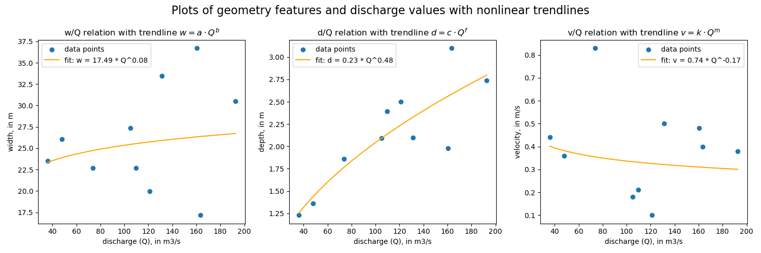The Leopold & Maddock method is applied to the bank full states of the river reach, for the ten cross-sections. No clear relation, in the form of the Leopold equations, is found. Plots of the three geometry characteristics and the corresponding discharges, are given in Figure 32.

Figure 32: Plots of the Leopold & Maddock relations between discharge and certain geometry characteristics

The fitted parameters are: $a=17.494, b=0.081, c=0.225, f=0.479, k=0.745, =-0.173$. The set of conditions is not met for these parameters, and gives a negative result for a tolerance of 20%. It can be seen in the plots, that especially the width and velocity parameters do not result in a good relation with the discharge. It can be concluded that these results are not useful.

With the determined parameters, the discharge per cross-section for the bank full state of the river reach, can be determined for all three of the relations, as well as for the average of these three. The results are given below, in Table 4, together with the calculated discharges based on Manning’s equation. It is noted that the values vary highly and the result is unreliable, which is to be expected with the result of the parameters above. It is also noticed that the Leopold relation between velocity and discharge gives the best result, and is in the same order of magnitude as the discharges determined based on Manning.

Table 13: Calculated discharges per cross-section for the Leopold & Maddock method

|  |  |  |  |  |  |
| --- | --- | --- | --- | --- | --- |
| Cross-section | Manning discharge [m3/s] | Leopold discharge, based on width [m3/s] | Leopold discharge, based on depth [m3/s] | Leopold discharge, based on velocity [m3/s] | Leopold discharge, average [m3/s] |
| 1 | 105.1 | 260.78 | 104.87 | 3764.2 | 1376.6 |
| 2 | 73.87 | 25.419 | 82.206 | 0.53426 | 36.053 |
| 3 | 47.83 | 139.83 | 42.751 | 67.713 | 83.431 |
| 4 | 131.3 | 3171.1 | 105.92 | 10.085 | 1095.7 |
| 5 | 160.6 | 9954.3 | 93.671 | 12.777 | 3353.6 |
| 6 | 109.9 | 25.280 | 138.77 | 1540.3 | 568.11 |
| 7 | 36.01 | 39.917 | 34.660 | 21.159 | 31.912 |
| 8 | 121.2 | 5.1119 | 152.44 | 113610 | 37923 |
| 9 | 163.5 | 0.79271 | 238.88 | 36.765 | 92.147 |
| 10 | 192.6 | 988.16 | 184.60 | 49.495 | 407.42 |
| AVERAGE | 114.2 | 1461.1 | 117.88 | 11911 | 4496.8 |

Appendix C. Student input installation and functioning of the FEWS

# Sensor Installation

## Respondent 3

* Under the bridge, water resistant
* Electric poles
* Theft-proof design – tall structures (mounted)
* Alarm system – integrate sensor alarm
* Durability – cameras made of corrosion resistant materials
* Power supply – solar panels
* Choosing right sensor – ultrasonic (for flood detection)
* Real time data transmission

## Respondent 4

In a river to monitor water pressure, in the river, height and velocity

Theft proof: Build a permanent concrete structure or a station adjacent to the river and equip with security sensor

## Respondent 6

Housing and mounting:

* Temper proof enclosure – place the sensor inside a reinforced, tamper-resistant enclosure made from materials like stainless steel or hardened plastic, prevent easy removal or tampering
* Power supply: Battery backup in areas where the power supply might be interrupted, install a battery backup for main

## Respondent 8

How to install a sensor or camera

* Next to residential, near a water body
* Under a the bridge
* Cage
* Concrete pillar

## Respondent 9

* It should be installed close to a water body for effectiveness and certainty
* It should also be installed close to a public institution for security purposes
* Solar panels

# Communication of the warning

Mentioned options:

* Siren
* Radio
* Via text on a telecom
* Whatsapp
* Local media
* Television
* Large fonts on a billboard
* SMS alert
* Car with speaker
* TikTok

Of which siren was mentioned most, radio second.